Possible Contingencies in CTU Operations
1 | Stripper Failure (Coil Tubing - Single Stripper)
2 | Stripper Failure (Coil Tubing - Dual Stripper)
3 | Pinhole (in Coil Tubing) at surface
4 | Coil Tubing parted at surface
5 | Coil Tubing parted down-hole
6 | Coil Tubing Collapse
7 | Coil Tubing Runaway while RIH
8 | Coil Tubing Runaway while POOH

Increase Hydraulic Pressure on Stripper

Leak Stopped

NO
YES

Assess, Discuss further Operation

Stop Pipe Movement & Circulation

Apply Injector Brake

Shut In Well at Choke & Wing Valve if Open

Close Slip & Pipe Rams

Bleed off above Pipe Rams

Leak Stopped
YES

Replace Stripper Rubber & Pressure Test

Assess, POOH &
Secure Well

Shallow
NO

CT Depth

Deep
Pick up enough to ensure pipe drops clear of X-Mas Tree when cut

Equalize Pressure.
Open Pipe Rams & Slip Rams

Continue Further Operations

Operate Shear/Seal Rams of Shear Seal BOP (If Fitted) or Shear Rams of Quad BOP. If Shear Rams of Quad BOP are operated, pick up the pipe enough to ensure the Blind Rams can be closed to seal the well bore

Secure Well & Repair Stripper
Assess, Discuss to Fish Coil




YES
Leak Stopped
NO
Close Lower
Stripper
Assess,
Discuss further Operation
YES
Shallow
Leak Stopped
CT
POOH &
Repair Upper Stripper
NO
Deep
Circulation
Continue Further Operations
Bleed off above Pipe Rams
Equalize Pressure.
Open Pipe Rams & Slip Rams
YES
Leak Stopped
Replace Stripper
Rubber & Pressure Test
NO
Increase Hydraulic Pressure on Upper Stripper
Stop Pipe Movement &
Apply Injector Brake
Shut In Well at Choke & Wing Valve if Open
Close Slip & Pipe Rams
Pick up enough to ensure Pipe drops clear of X-Mas Tree when cut

Operate Shear/Seal Rams of Shear Seal BOP (If Fitted) or Shear Rams of Quad BOP. If Shear Rams of Quad BOP are operated, pick up the pipe enough to ensure the Blind Rams can be closed to seal the well bore

Secure Well & Repair Stripper
Assess, Discuss to Fish Coil

Pinhole (in Coil tubing) at surface

Pinhole above While RIH Pinhole above While POOH Hole formed in the CT downhole

Monitor CT pressure & observed Check Valves are holding. Do not allow pressure to bleed below collapse pressure for CT

Check Valves Holding
YES

POOH until Leak point is back on Reel
NO NO
Severe
Leak

YES
Close Slip & Pipe Rams

POOH

Displace Reel to Water if there is hazardous fluid in Reel (e.g.
Acid)
Operate Shear Rams to Cut Pipe

Close Blind Rams

POOH & Replace Reel

Rig down Injector & remove Leaking Pipe

Circulate well to Kill Fluid through pipe left in-between the blind & pipe rams

Rig up Injector (with New Pipe) to fish Old Pipe

Attempt to spool excess coil back on to the reel to prevent it from swinging around. At the same time use the Injector to pull the other end back onto the Gooseneck

Stop injector and close the pipe and slip rams. Manually lock the rams if safe to do so

Check Valves Not Holding Or Danger of Fluid Release
NO
Monitor SIWHP & Prepare for Fishing Job

YES

Operate Shear Rams to Cut Pipe

Monitor whilst crew member stands by ready to follow the designated cutting method if leak re-occurs

Close Blind Rams

Rig down Injector & remove Leaking Pipe

Circulate well to Kill Fluid through pipe left in-between the blind & pipe rams

Rig up Injector (with New Pipe) to fish Old Pipe

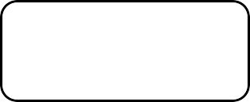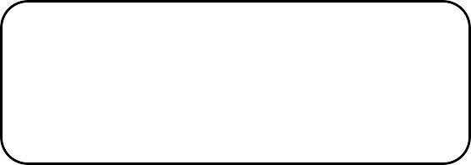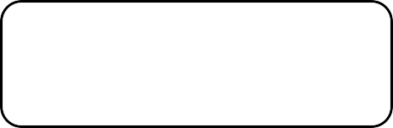
Parted tubing will be indicated by a
loss of weight and reduction in circulating pressure
Maintain low rate circulation at all
times to prevent hydrocarbons from entering the coil
Estimate length of coil left in the well
from pick-up and hanging weight
Pull out of hole slowly until it is
estimated that the end of the reel is just above the Swab Valve
Attempt to close the swab by counting turns. If not close (coil
across the valve) open the valve again & pick up CT equal to or a little shorter than the length of the riser and try the valve again.
Repeat until it is possible to close the valve.
Close Master Valve
Bleed off Riser Pressure &
Rig Down
Prepare for
Fishing Operations


Indications of CT Collapse are:-

- Increase in pump pressure
- Increase in tension measured on the stripper bushing
- Gripper is slipping
- Increase in tubing weight
Lower the coiled tubing into the hole
and place good pipe across the BOP rams
Close and lock the slip & pipe rams
Test slip rams by slowly
reducing the load on the injector
Kill the Well
Assess & Discuss to Recover Coil

Well Services Emergency Response Plan | Page 21 of 24 | Revision 1.0


Increase the traction system pressure
YES
CT Stopped

NO
Apply the "Emergency Traction" pressure from the priority hydraulic system. Keep the injector control in the “Run in Hole” position
Assess &
Discuss further Operation
YES
CT Stopped

NO
Increase the hydraulic pressure to the maximum setting in the stripper system
Assess &
Discuss further Operation
YES
CT Stopped

NO
Assess &
Discuss further Operation
area

Move Non-essential personnel to safe Area
Operator to Evacuate to safe

When CT has hit the bottom of the well, close the pipe & slip
 rams
Determine damage in
CT downhole by pumping
YES
Assess &
Discuss Options
NO
Repair Injector


System
Open Pipe & Slip rams
Slowly POOH

CT Runaway while Pulling out of Hole

Move Non-essential personnel to safe Area

Increase the traction system pressure

YES
CT Stopped Assess &
Discuss further
Operation
NO

Apply the "Emergency Traction" pressure from the priority hydraulic system. Keep the injector control in the “Pull Out of Hole” position

YES
CT Stopped Assess &
Discuss further
Operation
NO

Increase the hydraulic pressure to the maximum setting in the stripper system

YES
CT Stopped Assess &
Discuss further
Operation
NO

Operator to Evacuate to safe area
When CT has been thrown out of the hole, assess & if feasible, close the blind rams and wellhead valves

