Quick guide to running Sondex/GE Noise tool on Warrior
These screenshots are taken from a Warrior 8 system but Warrior 7 is identical as far as operating is concerned.
Firstly ensure that you have an up to date Warrior installation. If not you can download the software from SDS (if you have a STIP panel etc) or if Sondex supplied from https://www.geoilandgas.com/wireline-systems-downloads
Please ensure you download the appropriate file – there are Warrior 7 & Warrior 8 versions. The unzip password for the Warrior 7.10 installation = rabbit.
It is possible to update an older installation (pre 7.10) to include the Noise tool but it is easier to install 7.10 – it will not wipe out any of your existing settings.
Start Warrior Acquisition as normal & select the appropriate service e.g. Sondex Ultralink.
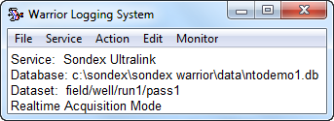
Select the correct Noise tool either NTO008 or NTO009 on the tool diagram with other tools as appropriate e.g.
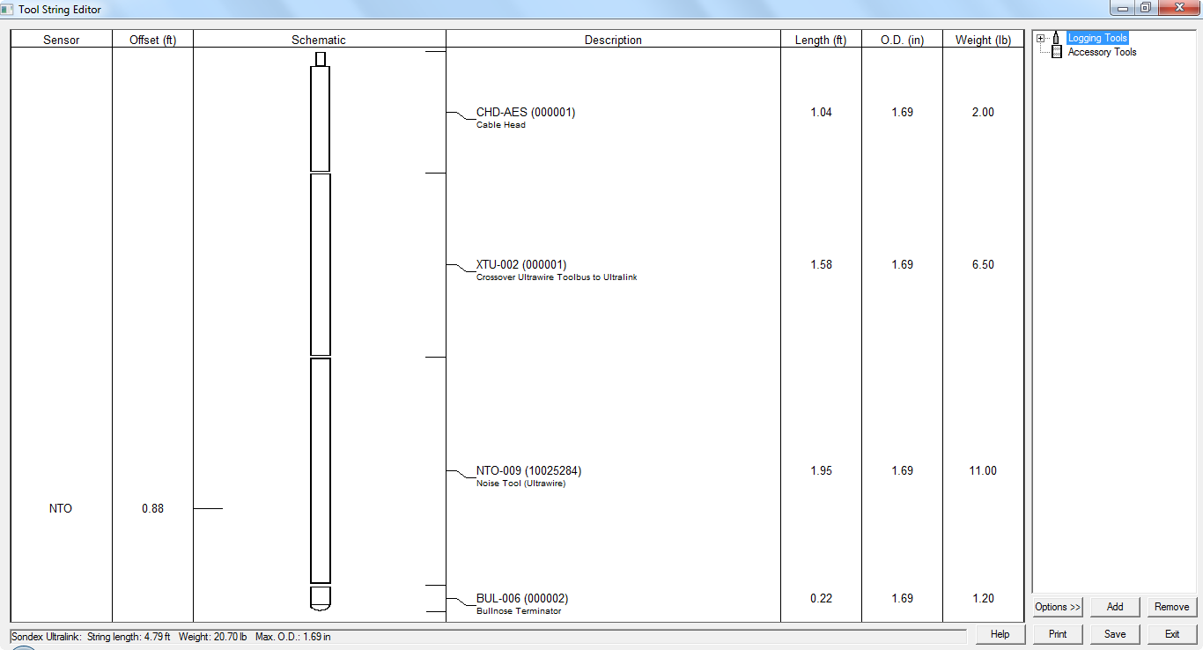
Power up the toolstring & check its communicating OK using Monitor/Devices/USBULD
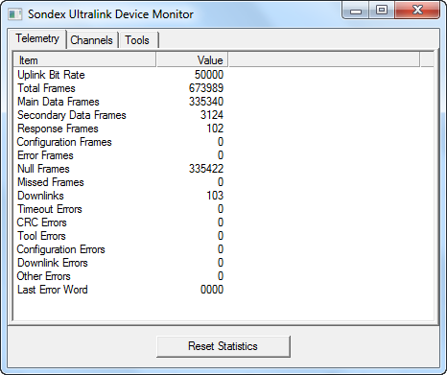
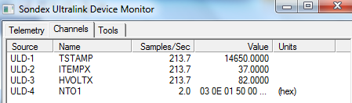
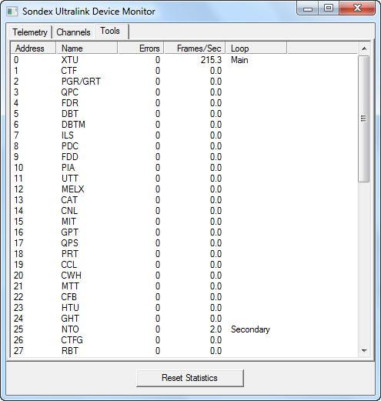
Then select Monitor/Tools/NTO
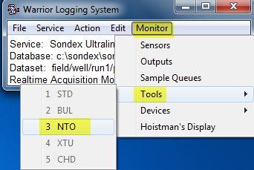
Which will launch the following windows:
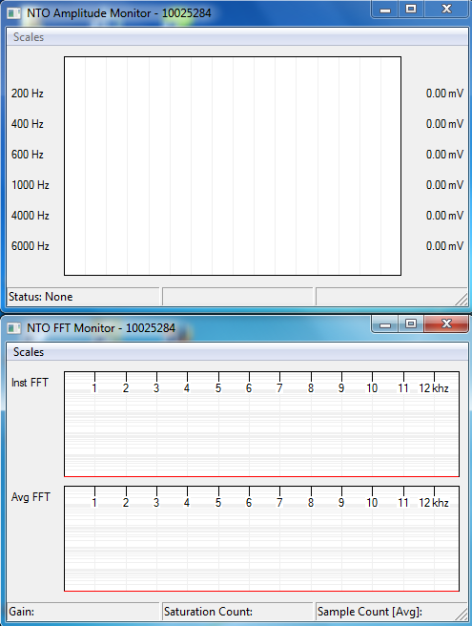
Please check the scales are Linear/Logarithmic – the default is Linear/Linear but Linear/Log is better as it shows more dynamic range.
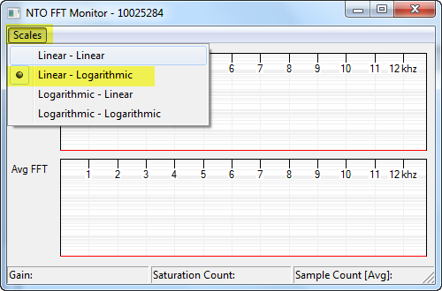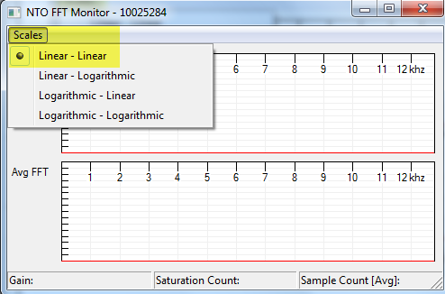
Nothing will be displayed yet as we have to start Preview using Edit/Tool Config/NTO
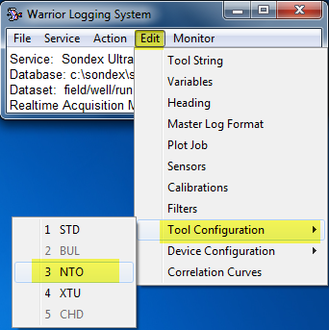
Which will launch the NTO control window:
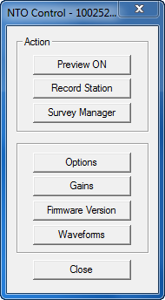
Click Preview on (it toggles on/off)
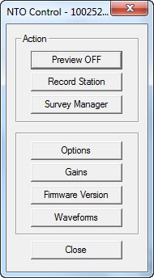 and then click on Gains which will launch the Gain window
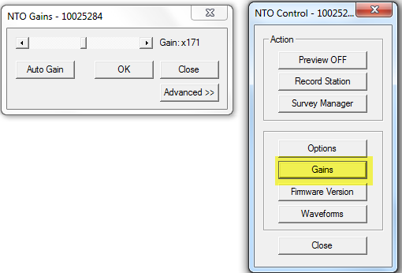
Experiment with changing the gain – either Autogain or Manual (the slider). An important point is that Autogain does not constantly check the signal, but only for 10 seconds after you click the Autogain button.The system then sets the gain to the appropriate level for the environment during the 10 seconds it was measuring. This works well for a constant level environment e.g. Stationary readings but is less satisfactory for moving readings. For recording while moving I prefer to use a manual gain of say 200 +/- (a medium value) and observing the FFT windows (see below for examples). The examples below are in air so the gain is at maximum but when the tool is in fluid e.g. in a wellbore the acoustic coupling will be much much better and a lower gain will be OK. The gain needs to be high enough to see a signal but not too high that the tool saturates. There is a Warrior curve called NTOSAT which records when the downhole digitizer saturates. A few saturations are OK but as few as possible is better. As trying to record Noise tool data whilst moving will generally have a changing environment it is difficult to get the gain perfect – i.e. high enough but without saturating. The Engineer should use his best judgement here. Recording stationary readings is easier as you can optimise the gain – best to use Autogain for stationary readings.
The example below is with a loudspeaker magnetically coupled to the noise tool and a 400Hz signal generator tone applied. If you have the tool in a “normal room” with background sounds you will see very little on the red bars but the FFT windows will show background noise. These bars show the amplitude of low pass filters, the bigger the bar the louder the sound. In the example below the 400Hz & 200 Hz bars are showing high values as the low pass measures that frequency & all those below.
The FFT window shows a clear peak at 400Hz – the rest is just background noise. The top FFT window shows instantaneous values and the bottom is an average over 10 samples.
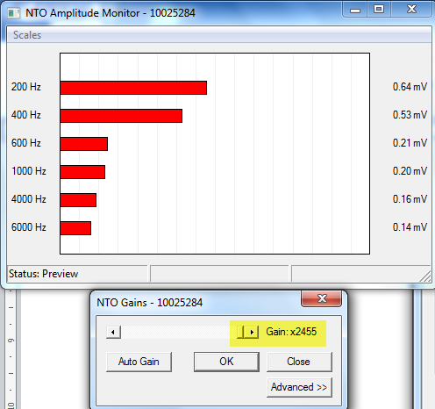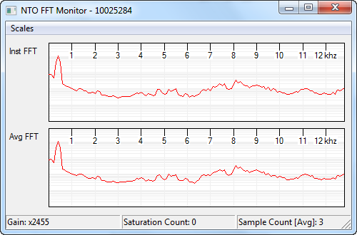
This example below is a 5000 Hz tone. You can see all but the 6000Hz bar are approximately equal, meaning that the sound is higher than 4kHz but lower than 6kHz.
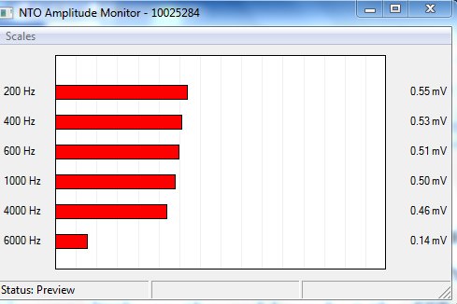
This example is 5kHz and the gain is set correctly – no saturations (Saturation count = 0) and the FFT window has the baseline roughly in the middle of the window.
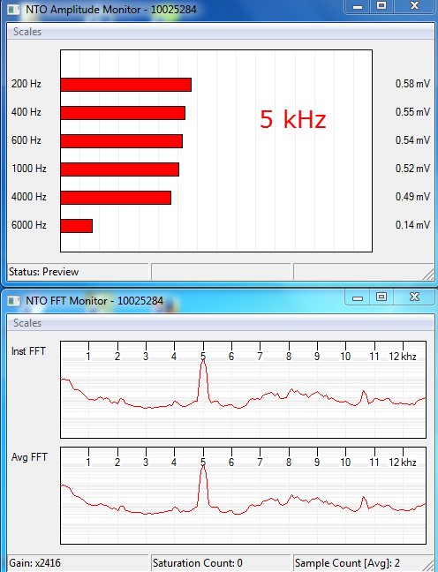
The log data has a left hand track showing the amplitude (loudness) of the sounds versus frequency (0 – 12.7 kHz). The louder the sound the brighter the colour. Purple is the quietest and red the loudest. As the sound gets louder it changes from purple through blue, green, yellow, orange, red. This enables the amplitude and frequency distribution to be easily viewed versus depth.
To record a time or depth file, click Action, Record and select the uwnoise.prs presentation. I have provided a more colourful version called “noiseuwgsbcolour.prs” which looks nicer but either will do.
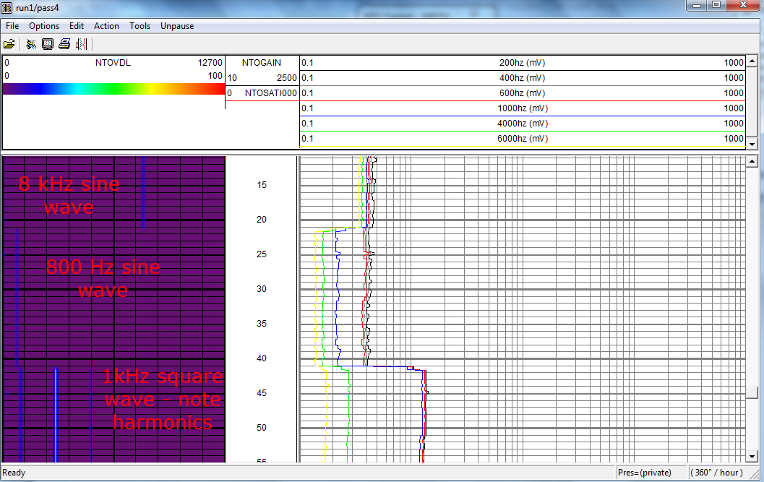
You can’t record a file whilst preview is turned on
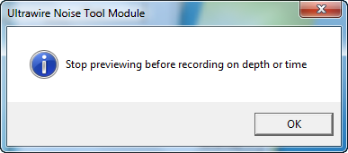
the preview toggles on/off – this is off as the action is to turn Preview ON
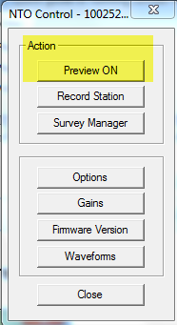
This is On as the action is to turn Preview OFF
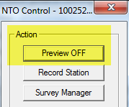

Log data from a well is likely to much noisier. In this example recorded whilst moving, the low frequency “road noise” shows up as the green bars at the low frequency end of the NTOVDL plot in the left hand P track.
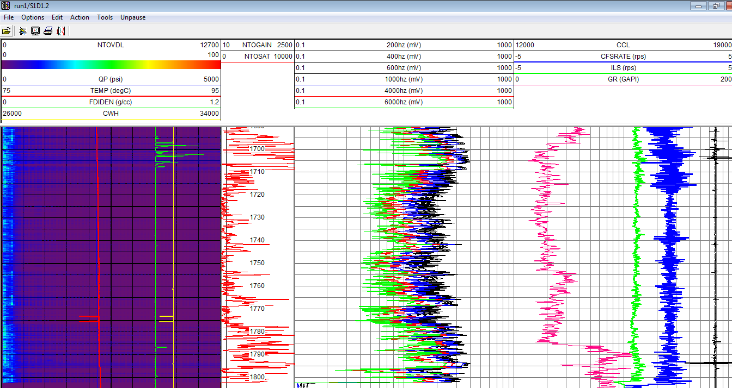
This is an example of a stationary reading recorded in time drive – the green road noise is missing as the tool is not moving. 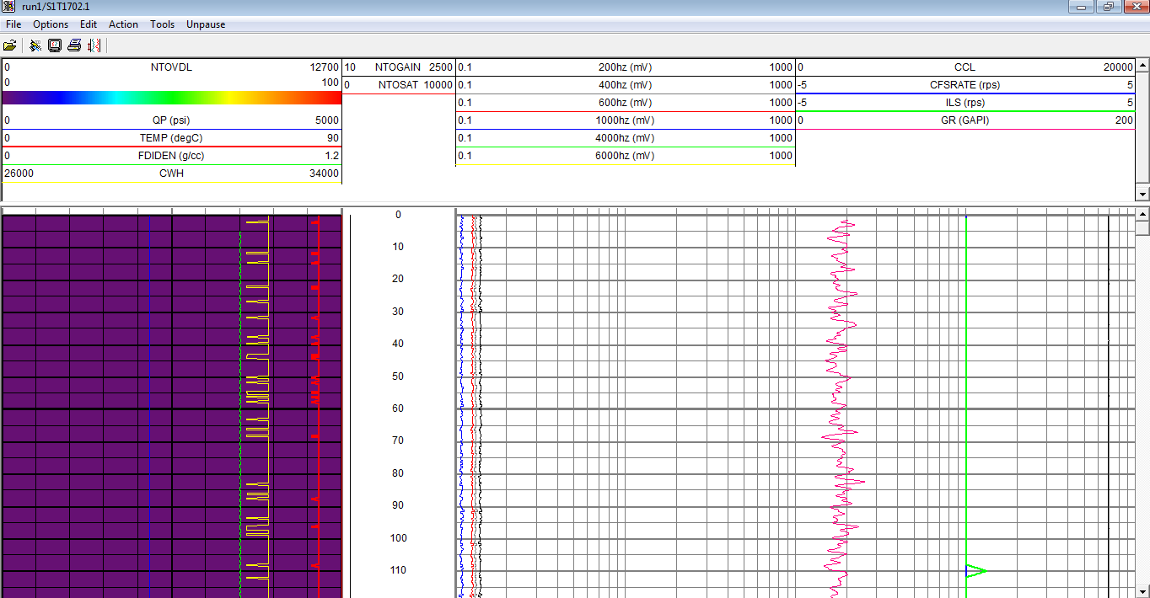

You can also record stationary readings using “Record station”. This will produce a stationary reading table. At present I prefer to record a time drive file as this enables the user to see any variation with time as opposed to an averaged value.
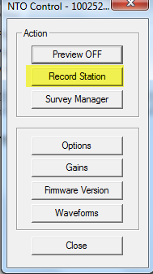
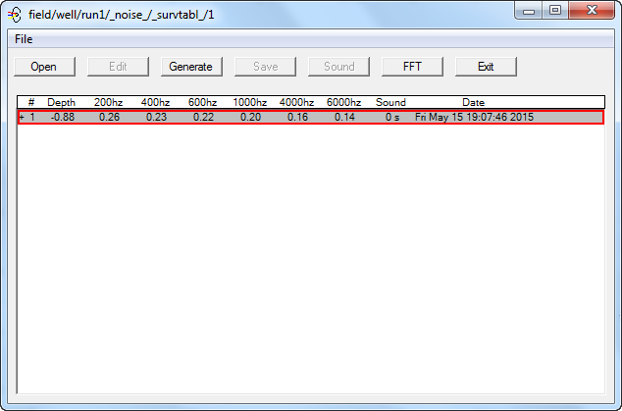

Simple Interpretation
Simplistically lower frequency leaks are typically liquid whereas higher frequency are more likely to be gas.

