SLICKLINE OPERATOR
WORKBOOK

IMPORTANT NOTE:

1. Your point of reference to complete this workbook may be obtained from the following
- Training Manual and any other training materials provided together with this workbook
- Your Trainer, Assessor (Slickline Operator), Verifier (FSM) or senior colleagues
- SOP / Quality Procedures & Processors
2. The completion of this Workbook is a joint effort and responsibility between you and your assessor therefore you have the obligation to request from your assessor to be assessed upon your completion of each topic
3. The completion of this Workbook is part of the MANDATORY requirements which you must fulfill to qualify for a promotion
4. Your training program is mostly self-driven, including this Workbook. It requires individual initiatives, dedication and commitment to complete the process.

NAME | Arvince Anak Terrence
DATE OF JOIN
CONTACT NO. | 013-5875538
RECEIVED DATE
DATE COMPLETED

B.1 OPERATIONS Legend: C-Competent, NME-Need More Exposure
Document No. | EXECUTE THE WELL SERVICES OPERATIONS | Assessment / Verification | Competency |  | Assessment  Date
Document No. | EXECUTE THE WELL SERVICES OPERATIONS | Assessment / Verification | C | NME | Assessment  Date

Form B 2.1 | ENTER THE WELL BORE
Form B 2.1 | - What do you understand by the term ‘SSV’ and ‘SC-SSV’? Explain what do you do with the SSV and SC-SSV hydraulic system when you have to work on a well? Explain why you have to do so?
Form B 2.1 | - Why do you have to carry out pre-checks on the service tools prior to well entry? List down the possible consequences if the pre-checks are not done.
Form B 2.1 | - Why do you have to ‘zero’ your toolstring every time you make a well entry? Where is your ‘zero’ reference point when you are working on:  - the rig floor  - a remote installation
Form B 2.1 | - How do you prepare your daily operation report? Give a copy of your daily report as a sample of your reporting format. Who should scrutinize your report and who is the final person to endorse your report when you are:  - on a production platform  - on a drilling rig
Form B.2.2 | RUN AND MANIPULATE SURVEY AND NON-SETTING TOOL STRING
Form B.2.2 | - How do you prepare a well for wireline entry, with respect to the platform Shutdown system? (Answer in description form & bullet points)
Form B.2.2 | - Why is it important to do that?
Form B.2.2 | - For all wireline well entry work it is mandatory for the control of the SSV to be transferred to the Well Services SWCP. Besides the above, what other essential precaution should be taken when running sinkers and non-setting surveys? Explain why? (Answer in bullet points)
Form B.2.2 | - When carry out a sand bailing operation using a pump bailer, describe the precautions to be taken, and the application of correct pumping technique to ensure that the bailer does not get stuck in the sand or buried by a potential sand bridge?  - Pre-operational checks (Answer in bullet points)  - Sand bailing (Answer in bullet points)
Form B.2.2 | - Explain why the integrity of the flowline valve is important during a wireline well entry work.  The integrity of the flowline valve is important during a wireline well entry work because :- (Answer in bullets points)  How will a badly passing flowing valve jeopardize:  - A non-setting survey job  - A setting survey job  c. A non-setting toolstring well entry work
Form B.2.2 | - When would it be appropriate to run a hydrostatic bailer?  State the conditions under which it could be effectively used to accomplish a work Objective. (Answer in bullets points)
Form B.2.2 | - When pulling a 16 feet tool-string back into the tubing tail how do you estimate the whereabouts of the rope socket with respect to the wireline re-entry guide? (Answer in description form)
Form B.2.2 | - Describe the mathematical steps to estimate the length of the wire left or available on a wire-line reel skid.  Legends:-  A = Flange to core distance (cm) B = Drum core distance (cm)  C = Flange to Flange (cm) D = Flange to top of wire (cm)  d = diameter of wire (cm) Pi of a circle + 3.1416  Formula for length of Wire in the Drum when neatly spooled is  A-D x C x Pi (( A-D ) + B )  d d
Form B.2.2 | - Why is it important to establish correlation of tubing accessories depth with well diagram depth during well entry work?  Describe how you could achieve this by wireline means?
Form B.2.3 | INSTALL AND RETRIEVE DOWNHOLE ASSEMBLIES
Form B.2.3 | - What are the checks that should be carried out prior to running an ‘XX’ or ‘PR’ (XN or RN) lock mandrel? Name five.  (Answer in bullets points)
Form B.2.3 | 2. Describe, with the aid of a diagram, how a hydraulic jar works.  Please see the attachment on the next page.  Answer:  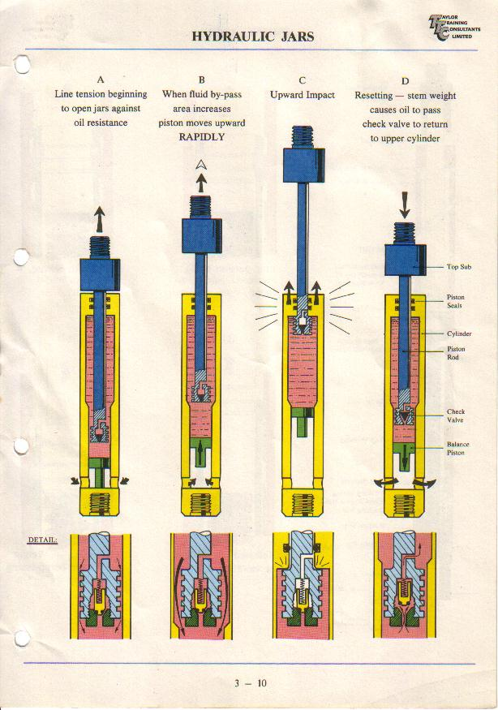
Form B.2.3 | 3. What is the difference between the overloaded type (A) and the plain type (B) slips used in conjunction with the 3/16” slip type braided line rope socket?  Overloaded type (A) slip  Plain type (B) slip  How many types of breaking strength slips are available and what are they?
Form B.2.3 | 4. What are the essential checks that should be carried out before assembling a wireline toolstring? Name six. (Answer in bullets points)
Form B.2.3 | 5. Describe how to make up, run, set and test a WR SCSSV. You can choose the type and either oil well or gas well. Also highlight the telltale signs in terms of tool, wireline and pressure indications to confirm that the valve has been properly set and installed.  Type of WR SCSSV: CAMCO B7 to install in an oil well  Pre-operational B7 valve checks (Answer in bullets points)  Preparation for running the B7 valve (Answer in bullets points)  Setting the B7 valve (Answer in bullets points)  Differential pressure test on B7 valve (Answer in bullets points)  Slam test on B7 valve (Answer in bullets points)
Form B.2.3 | 6. Describe how to make up, set and test a downhole plug. You can choose the type and either an oil well or gas well. Also highlight the telltale signs in terms of tool, wireline and pressure indications to confirm that the plug has been properly set and installed.  Type of downhole plug: “XX” plug to install in an oil well  - Preparation for the Lock Mandrels  (Answer in bullets points)  - Assembling the lock Mandrel to the “X” running tool  (Answer in bullets points)  Setting the 3” Otis XX plug  (Answer in 14 steps)
Form B.2.3 | 7. In a vertical well, you are to equalise and pull a 3” plug at 7656 ft. Reservoir pressure = 2800 psig. Liquid level is detected at 1867 ft. Liquid gradient of well = 0.28 ppf. CITHP = 980 psig. Ignoring pressure exerted by gas column and assuming that the liquid level remains unchanged, calculates the final CITHP after you have RIH and have properly equalised the plug. Show the mathematical steps on how you arrived at your answer.  Data: Fluid level: 1867 ft.  Plug to be pulled: 7656 ft.  Expected reservoir pressure: 2800 psig  Surface THP: 980 psig
Form B.2.3 | 8. What is the most appropriate instrument you can use to monitor pressures during a plug equalization process, and state the advantages over a conventionnel pressure gauge?  (Answer in bullets points)
Form B.2.3 | 9. How do you confirm that a WR SCSSV is proper set or installed in its landing nipple with respect to tool, wire line and pressure indication?
  No | Tool indications | Wireline indications | Pressure indications
  01
  02
  03 |  |  | .
  04
Form B.2.3 | How do you confirm that a downhole plug is properly set or installed in its landing nipple with respect to tool, wire line and pressures indication?
  No | Tool indications | Wireline indications | Pressure indications
  01
  02
Form B.2.4 | INSTALL RETRIEVE AND MANIPULATE CIRCULATING AND COMMUNICATION DEVICES.
Form B.2.4 | 1. What are the checks should be carried out on a 142BO positioning tool prior to running it into the well?  Pre-operational checks  (Answer in bullets points)
Form B.2.4 | 2. What features and components on the 42XO positioning tool allows it to reciprocate between selective and non selective position? Explain how is this achieve? (Answer in bullets points)
Form B.2.4 | 3. When opening a SSD why it is not recommended to open the link jar fully?
Form B.2.4 | 4. When installing a GLV, are the two sets of tangential shear pins installed on the Camco “GA-2” running tool jar up to shear or vice versa?
Form B.2.4 | 5. After installing/setting a GLV in the SPM is it necessary to shear off the locating finger’s pin on KOT to enable release from the particular SPM and also passing through other while POOH. Explain.
Form B.2.4 | - Describe how to install/set a BKR-5 in the first SPM. You are to include tool-string configuration, services tools selection, type/size of shear pins, pressures checking, running & pulling speed and confirmation of proper installation.  - To install a BKR-5 in the first SPM  a) Tool-string configuration from top to bottom  (Answer in bullets points)  b) Serviced Tools selection  (Answer in bullets points)  c) Type & Size of Shear pins  (Answer in bullets points)  d) Pressure checking  e) Running and Pulling speed
Form B.2.4 | f) Confirmation of proper installation  g) To install BKR-5 in the first SPM  2) To retrieve a BK-R 5 from the first SPM.  a) Tool-string configuration from top to bottom.  b) Serviced Tools selection  c) Type & Size of Shear pins  d) Pressure checking  e) Running and Pulling speed.  f) Confirmation of proper installation  g) Mode of retrieving BKR-5 valve from first SPM
Form B.2.4 | 7. Describe how to close a 3.5” SSD using a 42XO positioning tool. You are to include Tool-string configuration, size of bottom cap, function testing of tool, maximum allowable line extension, how to accomplish effective and productive jarring and confirmation of SSD fully closed.  a) Tool-string Configuration from top to bottom.  b) Serviced Tools selection  c) Pressure checking  d) Function test of the tool.  e) Maximum allowable line tension  f) To accomplish effective and productive jarring and confirmation of SSD fully closed.
Form B.2.4 | 8 Describe how to open a 2.7/8” SSD using a 142BO positioning tool. You are to include Tool-string configuration, function testing of tool, pressure differential issue, manipulation of the tool-string, precautions during jarring operations and proper monitoring of tubing pressure.  To open a 2.7/8” SSD using a 142BO positioning tool.  a) Tool-string Configuration from top to bottom.  b) Serviced Tools selection  c) Pressure differential issues  d) Pre-check and Function test of the tool  e) Mode of opening the 2.7/8” SSD
Form B.2.5 | PERFORM FISHING OPERATIONS
Form B.2.5 | 1. For a wireline fish which already been established to have clear fishing neck, what initial pulling tool would you use for:  Note: Disregard the size of the fishing neck and the tool to be run for this question. Give your reasons.  - a fish with an external fishing neck.  - a fish with an internal fishing neck.
Form B.2.5 | 2. What is the important factor you have to consider prior to the selection of lubricator / BOP configuration for a wireline fishing operation, and what are the consequences of not using the correct length?
Form B.2.5 | 3. What should the minimum recommended diameter be for the measuring wheel, hay pulley and stuffing box sheave used in conjunction with:
  No | Wireline | Measuring Wheel | Hay Pulley | Stuffing Box sheave
  A | 0.092" slick line
  B | 0.108" slick line
  C | 0.125" slick line
  D | 3/16" braided line
Form B.2.5 | 4. After rigging up and prior to running in hole, to what pressure should the lubricator / BOP assembly be tested to and for what duration?
Form B.2.5 | 5 How and where is the pressure normally introduced into the lubricator/BOP assembly?
Form B.2.5 | 6. A tubular jar is normally used in place of a mechanical jar (link jar) when fishing for wire. Explain the reason behind this philosophy
Form B.2.5 | 7. How and when do we record the weight reference of the fishing toolstring prior to latching onto the fish?
Form B.2.5 | 8. In checking the static weight of the tool-string state whether any difference would be encountered when checking the weight during the upward pull and downward run. Can both weight references be used and explain under what condition are each applicable?
Form B.2.5 | 9 What is the maximum line pull allowable for the following wires used in SSB/SSPC, and state their minimum-breaking load  Answer:
  No | Wireline | Max. Line Pull | Min. Breaking Load
  A | 0.092" Bridon U.H.T Bright
  B | 0.108" Bridon U.H.T Bright
  C | 0.108" Bridon Supa 70
  D | 0.108" Bridon Supa 75
  E | 0.125" Bridon U.H.T.3
  f | 3/16" Bridon Dyform 1 x 19 (9x9x1)
Form B.2.5 | 10 Give five circumstances under which it becomes necessary to employ a wire cutter for the purpose of cutting the wire-line in the well?
Form B.2.5 | 11. List out three conditions whereby it is necessary to use an overshot to grip down-hole tools in a fishing situation.
Form B.2.5 | 12. With respect to safety and procedure what type of pulling tool should be used in conjunction with the non-releasable overshot when running it into the well?

Assessed By: |  | Verified By
Name |  | Name
Position |  | Position
Date |  | Date

