DIMENSION BID (M) SDN BHD
CASED HOLE SERVICES
E-LINE INTERVENTION TECHNOLOGIES
BEKOK B-06
WELL LEAK DETECTION
PREPARED BY
PREPARED BY | RAHMAT RAFE  Technical Sales and Support Eng  E-line Cased Hole Services  Dimension Bid | FARHAN HARUN  Field Engineer II  E-line Cased Hole Services  Dimension Bid
REVIEWED BY
REVIEWED BY | AZZAD HAFIZ ABD LATIF  Senior Log Analyst  E-line Cased Hole Services  Dimension Bid | WIN NAING OO  Field Service Manager  E-line Cased Hole Services  Dimension Bid
APPROVED BY
APPROVED BY | AHMAD ZAWAWI BIN ABDUL RAJAB  EIC-PM9  PCSB | HAZIQ FARHAN MOHD ZAKI  EIC-PM9  PCSB
APPROVED BY | CHOI YEE XIONG  Head of Cluster I  PCSB

 |  | TABLE OF CONTENT | PAGE
1.0 |  | SUMMARY OF JOB | 3
2.0 |  | WELL BACKGROUND | 3
 | 2.1 | Job Objectives | 3
 | 2.2 | Well Schematic | 4
3.0 |  | METHOD OF CONVEYANCE AND SURFACE EQUIPMENT DETAILS | 5
4.0 |  | GENERAL SAFETY REQUIREMENT | 6
 | 4.1 | General | 6
 | 4.2 | Job Safety Analysis | 6
 | 4.3 | Well Control | 6
5.0 |  | E- LINE OPERATING PROCEDURE | 7
 | 5.1 | Tool Box Meeting | 7
 | 5.2 | Well Handover | 7
 | 5.3 | Eline Rig Up | 8
 | 5.4 | MIT & SGS | 10
 | 5.5 | Rig Down and Well Handover | 12
 |  | Appendix
 |  | Attachment 1: PCE Rig Up Diagram | 13
 |  | Attachment 2: BHA MIT & SGS | 14
 |  | Attachment 3: WEST Report | 15
 |  | Attachment 4: Cable Stuck Recovery Flow Chart | 26
 |  | Attachment 5: Tool Stuck Recovery Flow Chart | 30
 |  | Attachment 6: ART Release Procedure | 31
 |  | Attachment 7: Emergency Contact Number | 31

- SUMMARY OF THE JOB
The objective of Noise Tool Logging is to identify the source of leakage causing a pressure build-up in the A-Annulus of the Bekok B-04.
ELINE RUN OVERVIEW
 | RUN# | STEP & RUN
 | 1 | Slickline to run Tubing Clearance for ELINE operation
 | 2 | ELINE to run Noise Tool Logging

- WELL BACKGROUND
Well | Bekok B-04
Tubing Size | 3-1/2” 9.3 ppf N-80 EUE
Casing Size | 7” K55, 23 ppf @ 9015ft-MDRKB
Min ID | 2.690” at No-Go @ 8621.1ft-MDRKB
Maximum Deviation | 63 degree

  - Job Objectives

To identify the source of leakage causing a pressure build-up in the A-Annulus of the Bekok B-04.

Activity | Logging Interval
Activity | (m MDRKB) | (m BTHF)
WLD | Surface – 2632

  - Well Schematic
Well Schematic (B-04)
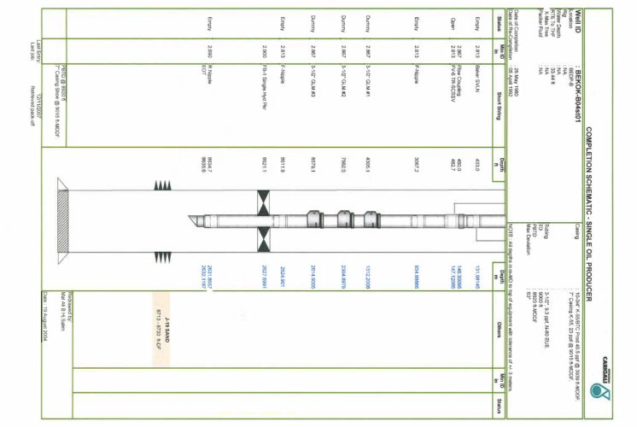

3.0 METHOD OF CONVEYANCE & SURFACE EQUIPMENT DETAILS
Jobs will be run using e-line. Following is the cable details;
- Nominal OD : 7/32-in (0.219 in)
- Cable type : Standard Service Mono Conductor cable
- Max breaking strength : 5600 Ibs
- Safe Working Load : 3360 Ibs
- Total Length : 21250 ft
For surface equipment, the standard e-line logging system will be utilized. This includes;
- ASEP Logging Cabin
- ASEP Winch Skid
- ASEP Powerpack
- ASEP Generator Skid
- Telescopic Mast (70 ft)
- Adex Zonex Zone 2 Air Compressor
- Adex Zonex Zone 2 Generator
- Pressure Control Equipment (PCE) Skid, 10k PSI WP
- Doghouse, Storage Boxes, Grease Drum Skid.

- GENERAL SAFETY REQUIREMENT
  - General
PCSB has a strong commitment to ensuring all operations are performed in a safe and environmentally responsible manner. All operations conducted in the course of any well operations shall be in accordance with the safety and environmental requirements specified by the following documents:

- PCSB Drilling/Wire line Standards and Guidelines.
- PCSB Health, Safety and Environment Policy Statements.
- ZETO Rules

PCSB has a stop work policy which should be followed at all times

  - Job Safety Analysis

JSA/JHA meeting shall be conducted prior to any well operations and prior to each run in the hole

  - Well Control

During the well intervention operations, control of the TR-SCSSSV will be removed from the wellhead control panel and will be controlled via the Slick line control panel on the main deck. The Actuated master valve will have a fusible cap installed and will not be activate to close in the event of an ESD.

In the event of ESD activation during the well intervention operations, PCSB Operations, PCSB wire line supervisor and DB personnel shall monitor the situation and if required, commence POOH with wire line equipment.

- E-LINE OPERATING PROCEDURE
Note:
This PCSB procedure is the master/overriding procedure, in the event of a discrepancy between PCSB procedure and service company procedure, the Well Site Supervisor and the PWE Engineer are to be consulted.
  - Tool box meeting
Tool Box Meeting must be held prior to initiating the electric line operation. All Personnel involved in the planning, supervising or execution of the program should attend the meeting and items to discuss as follow:
- The electric line program and procedures.
- Possible interface with other field activities.
- Safety aspect of the work and review JSA.
- Radioactive handling
- Ensuring that the necessary equipment, tools, and materials are available and are in operating condition.
- Field personnel that will be involved in the operation and how and when they may be needed.
- Personnel safety orientation

  - Well Hand Over
    - The well tubing clearance (drift run) and HUD check MUST be done using Slickline prior handing over the well to E-line Operation.
    - PCSB Operation to shut in gas lift to well at gas lift header (if required).
    - Allow well to produce to test until well stops flowing naturally.
    - PCSB Operation to shut in well at choke and production wing valve.
    - Close Lower Master Valve (LMV) and Crown Valve (CV)
    - Installed “Do Not Operate Tag” on LMV and CV and “Lock Out” tag on SSV. Subsequent operations on the LMV and CV will be handled by E-line crew until the well is returned to Operations.
    - PCSB Operation to close the TR-SCSSV and isolate the control line from its control panel. Subsequently, install a “Do Not Operate” tag on the TR-SCSSV control panel and gas lift SDV.
    - PCSB Operation to hand over well to E-line team.

  - E-Line Rig Up
    - Arrange and position surface equipment at the main deck. Do not block any escape route.
    - Locate the well. Remove existing well hatch cover and replace with working well cover. Only necessary personnel are on board during the hatch cover replacement.
    - Spot Telescopic Mast. Ensure mast’s outriggers support stand on flat surface and wood planks of sufficient length are available to cover any hole on the main deck resulting from the well cover change if any.
    - Erect the Telescopic Mast, always follow mast operating guideline. Secure the mast properly with all guy-wires supplied to strong platform structure.
    - Rig up upper and lower sheave wheels.
    - Rig up (R/U) lower section of riser to wellhead up to Quick Test Sub (QTS). Remain upper section of lubricator with GIH assembly laid down on the main deck. Refer Attachment 1 for rig up lubricator assembly diagram.
    - Raise Grease Injection Head (GIH) with numbers of lubricators depends on tool string length with additional minimum 5 ft for additional clearance. Watch for hanging hydraulic control lines and grease control lines.
    - Make up sinker bars (if applicable) to the logging head, ART and cap at the bottom.
    - Pull the tool string in the lubricator and prepare for PCE pressure test. Test Pressure (TP) must be 1.2 from the SITHP. Stab the QTS into BOP and make up connection.
    - Catch tool string in the tool catcher.
    - Pressure test PCE assembly by filling up with water and apply pressure by staging up every 200 psi to maximum 3000 psi. Wait for 10 mins at 3000 psi.
Note: Only Quick Test Sub (QTS) connection shall be pressure tested on subsequent tool rig up. Test Quick Test Sub with hand pump. Maximum pressure is 3000 psi and the pressure must hold minimum 10 seconds. No leakage acceptable. However, if other section of PCE connection is break off for some reason, step 5.3.11 must be repeated again.

    - On completion of the test, drain the test fluid to the closed drain. Bleed pressure and continue to inject grease injection pressure 1.2 X SITHP.

  - Run NTO in Condition 1 (1st Passes)
Note:
Condition 1, Run in shut in condition as for baseline for NTO
    - Make up toolstring as per diagram in Attachment 2.
    - Zero bottom nose of toolstring at main deck. Take note elevation to RKB.
    - Stab lubricator on to QTS. Pressure test on QTS connection up to 3000 psia for 10 seconds.
    - Pull cable head into TC. Ensure tool is engaged properly in TC. Note depth on smart monitor.
    - Open CV and LMV. Count turns to open valve.
Note:
Once the CV is fully opened, crack open the LMV initially until well pressure has stabilized inside the lubricator assembly.
    - Record SITHP and apply grease injection pressure for HGT (1.2 X WTHP). Observed hanging weight of tool string. Inspect the lubricator assy. and connection for any leaks. Verify minimal gas blow by from grease injector.
    - Release cable head from TC and RIH slowly until TR-SCSSV. Onsite supervisor must witness travelling thru TR-SCSSV.
    - Once the tool string has travelled past TR-SCSSV, RIH at maximum speed of 10 m/min and slowing down to 10 m/min to pass thru any GLMs and other well accessories.
    - Perform Z wrap diagram, record depth and pulling weight when cable reaches edge of drum.
    - RIH the toolstring at 10 m/min to depth 2632 m-MDRKB and record all sensors to identify any anomalies (change in gradient in temperature log) indicative of possible flow into tubing from annulus.
    - After reach at 2632 m-MDRKB, POOH and stop every 10m for 1 minute to record all sensors and specifically looking for an increase in response from the NTO.
Note:
If an increase in signal amplitude is noted, the Engineer will take additional readings to pinpoint the location of maximum amplitude
We are suspecting leak point at depth 2298.19 m MDRKB to 2303.19 m MDRKB
Make a station stop during POOH each 1m from depth 2308.19 m MDRKB to depth 2293.19 m MDRKB and stop 1 minute for each station stop
RIH tool 25 meter below suspect leak point. Make station stop during POOH each 1 meter. Each stop for 1 minute before and after suspected leak point

    - Replay the log and verify if data quality is OK. Send log in PDF to I-solution for verification.
    - If necessary repeat the logging. Otherwise POOH Observe tool arrival carefully by monitoring tool trap.
    - Once end of the tool passing tool trap, stop the winch after toolstring in lubricator. Start with another passes.
  - Run NTO in Condition 2 (2nd Passes)
Note:
Condition 2, run in shut in condition, and inject PCP to 1500 psi
Note:
Once the well is in a stable condition, the steps taken in the shut-in pass are to be repeated, with the Engineer watching for changes during RIH indicative of a change in the flowing regime due to a leak.
    - Make up toolstring as per diagram in Attachment 2.
    - Zero bottom nose of toolstring at main deck. Take note elevation to RKB.
    - Stab lubricator on to QTS. Pressure test on QTS connection up to 3000 psia for 10 seconds.
    - Pull cable head into TC. Ensure tool is engaged properly in TC. Note depth on smart monitor.
    - Open CV and LMV. Count turns to open valve.
Note:
Once the CV is fully opened, crack open the LMV initially until well pressure has stabilized inside the lubricator assembly.
    - Record SITHP and apply grease injection pressure for HGT (1.2 X WTHP). Observed hanging weight of tool string. Inspect the lubricator assy. and connection for any leaks. Verify minimal gas blow by from grease injector.
    - Release cable head from TC and RIH slowly until TR-SCSSV. Onsite supervisor must witness travelling thru TR-SCSSV.
    - Once the tool string has travelled past TR-SCSSV, RIH at maximum speed of 10 m/min and slowing down to 10 m/min to pass thru any GLMs and other well accessories.
    - Perform Z wrap diagram, record depth and pulling weight when cable reaches edge of drum.
    - RIH the toolstring at 10 m/min to depth 2632 m-MDRKB and record all sensors to identify any anomalies (change in gradient in temperature log) indicative of possible flow into tubing from annulus.
    - After reach at 2632 m-MDRKB, POOH and stop every 10m for 1 minute to record all sensors and specifically looking for an increase in response from the NTO.

Note:
If an increase in signal amplitude is noted, the Engineer will take additional readings to pinpoint the location of maximum amplitude
We are suspecting leak point at depth 2298.19 m MDRKB to 2303.19 m MDRKB
Make a station stop during POOH each 1m from depth 2308.19 m MDRKB to depth 2293.19 m MDRKB and stop 1 minute for each station stop
RIH tool 25 meter below suspect leak point. Make station stop during POOH each 1 meter. Each stop for 1 minute before and after suspected leak point

    - Replay the log and verify if data quality is OK. Send log in PDF to I-solution for verification.
    - If necessary repeat the logging. Otherwise POOH Observe tool arrival carefully by monitoring tool trap.
    - Once end of the tool passing tool trap, stop the winch after toolstring in lubricator. Start with another passes.
Note:
The Engineer is to monitor the level of noise caused by the flow of fluid around the tool, and ensure that the noise signal is not saturated, by selecting an optimal gain level. If a non-saturated signal cannot be achieved, the remaining data is to be recorded during an up log, and then proceed with the final shut in pass.

  - Rig Down and Well Hand Over

    - Rig down all wireline PCE and all associated equipment used in operation.
    - Install the tree cap. Crack open the well to check if there is any leak at tree cap connection with well pressure. Apply well pressure against the tree cap in stages of 200 psi (hold 1 min at each stage) to last recorded SITHP. Observe for any leak.
    - Reconnect TR-SCSSV to well head control panel and pressure test line to 4000 psi for 10 mins.
    - Remove fusible cap and hand over well back to PCSB Operation.
    - Housekeeping and prepare for next operation

ATTACHMENT 1: PCE RIG UP DIAGRAM
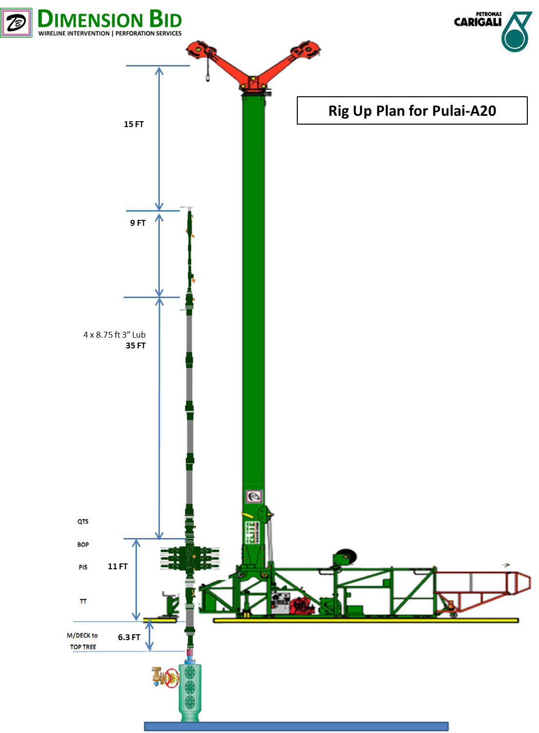
ATTACHMENT 2: MIT-SGS TOOL STRING CONFIGURATION
ATTACHMENT 3: WEST SIMULATION

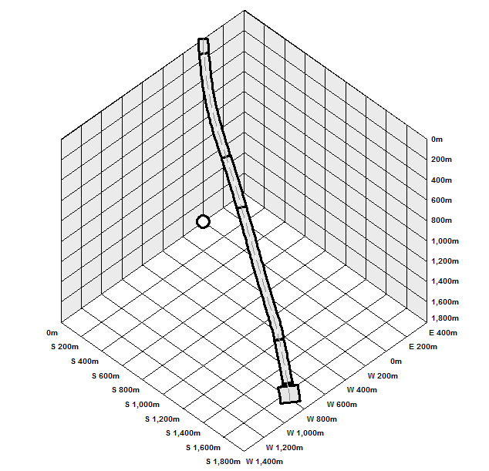

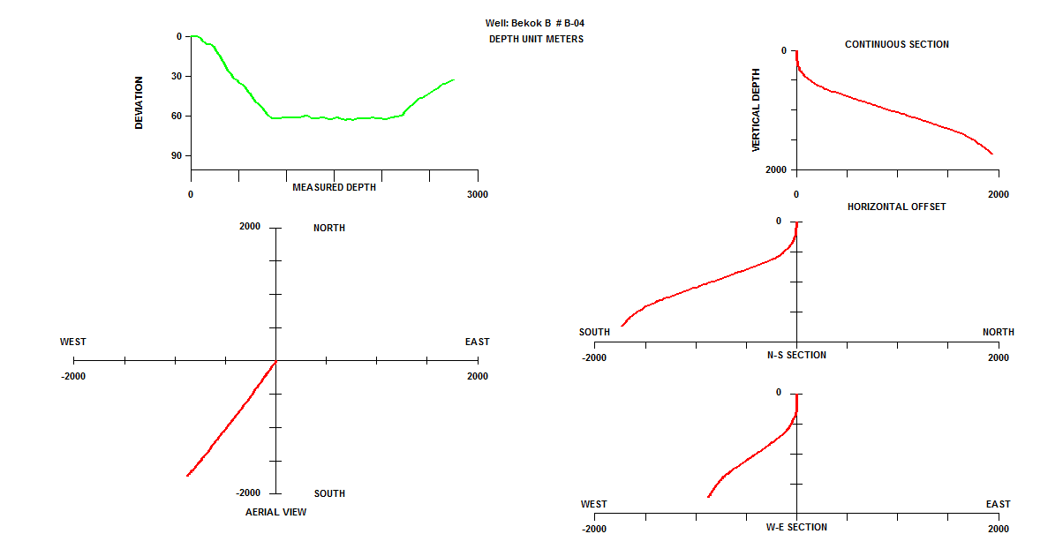

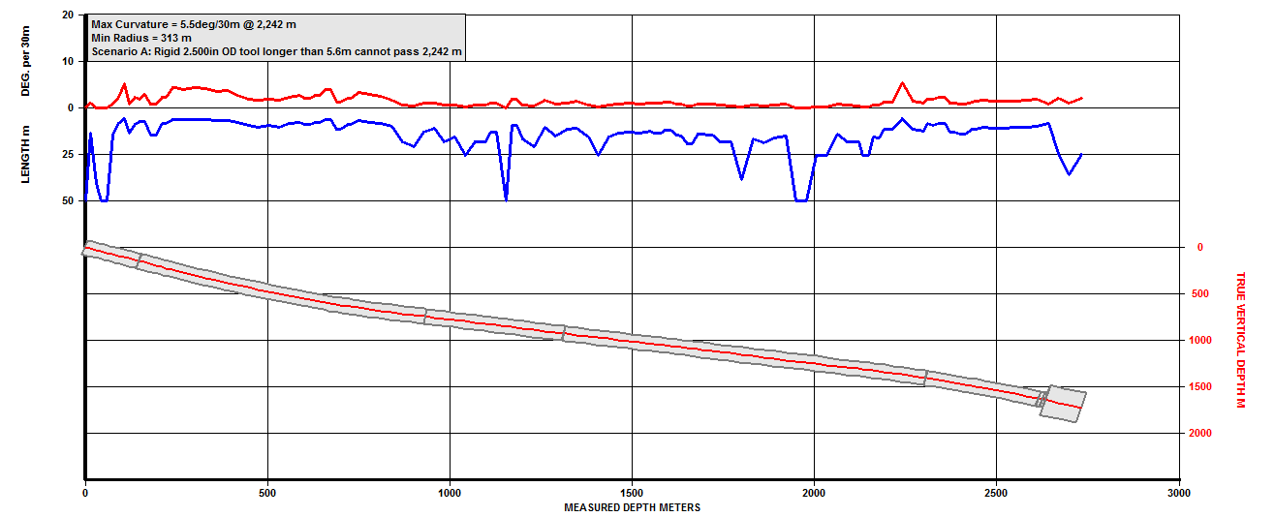

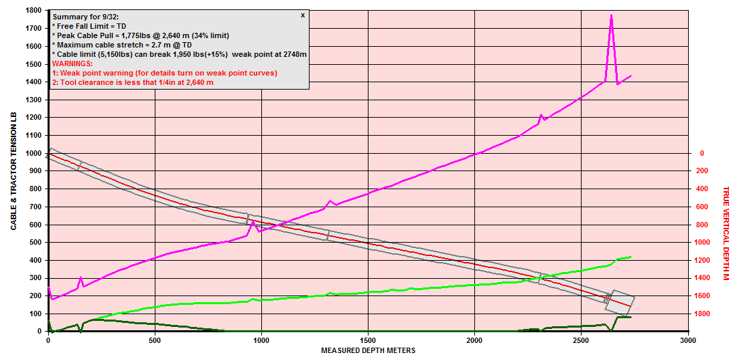

ATTACHMENT 4: CABLE STUCK RECOVERY CHART
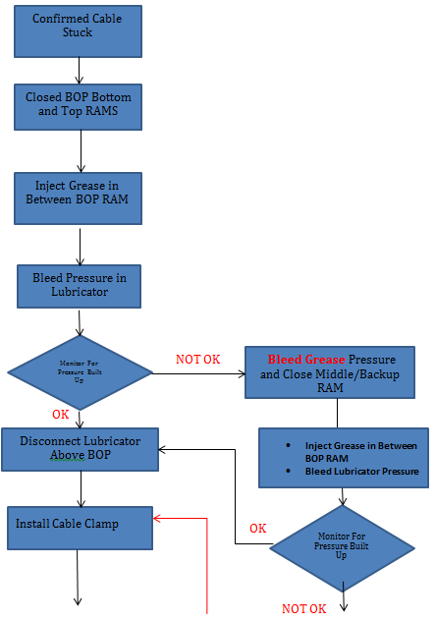

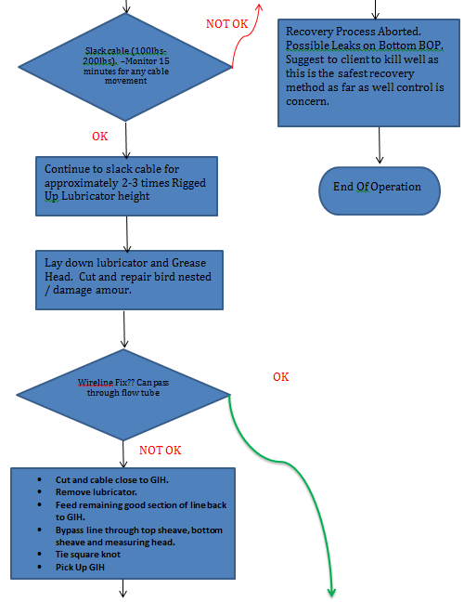
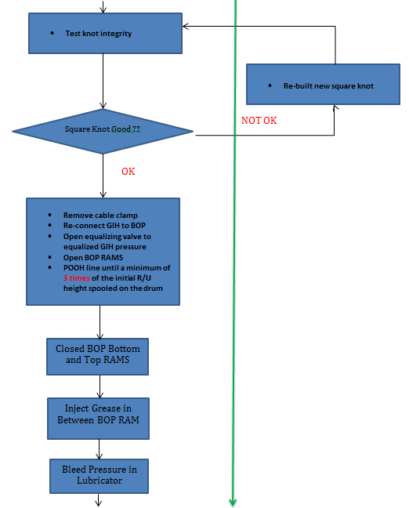

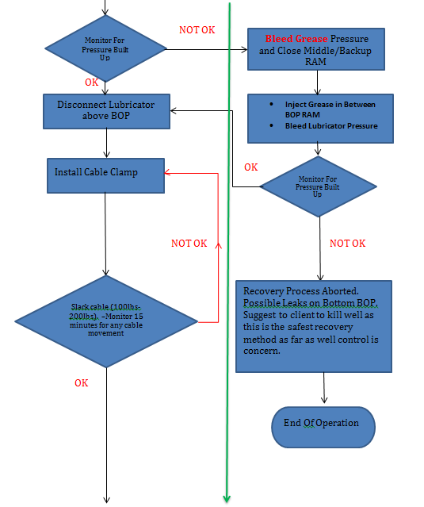

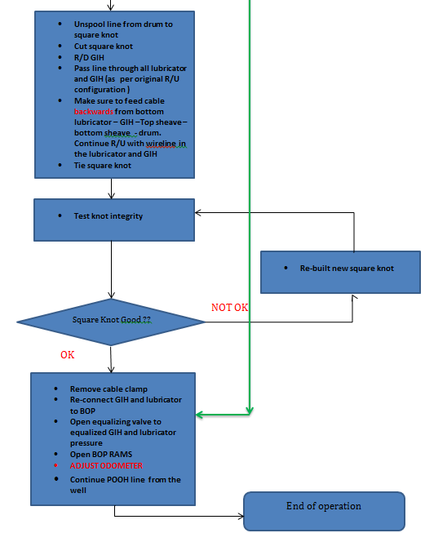

ATTACHMENT 5: TOOL STUCK RECOVERY CHART

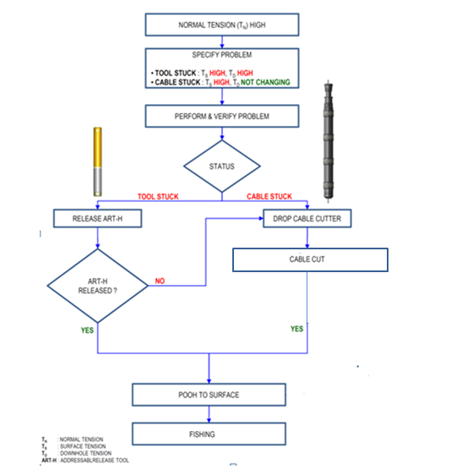

ATTACHMENT 6: ART RELEASING PROCEDURE

- Disconnect all surface power supplies.
- Confirm well pressure at ART depth is > 500 psi.
- Slacken off cable so there is no tension at the cable head.
- Connect the ACP (ART Control Panel) to the logging cable.
- Set ACP rotary switch to ‘Safety’ and switch on ACP.
- Confirm ACP current increases by ~11mA after 4-7 seconds.
- Confirm ACP LED’s cycle and appropriate LED’s remain lit.
- Select the tool to be released using the rotary switch.
- Press the ‘ARM’ button. Confirm the ARM LED Lights.
- Press the ‘RELEASE’ button. Confirm the current increases to between 60 and 150 mA.
- Monitor the current for sharp increase / decrease = Release.
- Release takes 2-3 minutes. If the current drops out < 3 minutes, switch off ACP and repeat step 5-11.
- Pull out of hole. Up to 400 lbs overpull may be required.

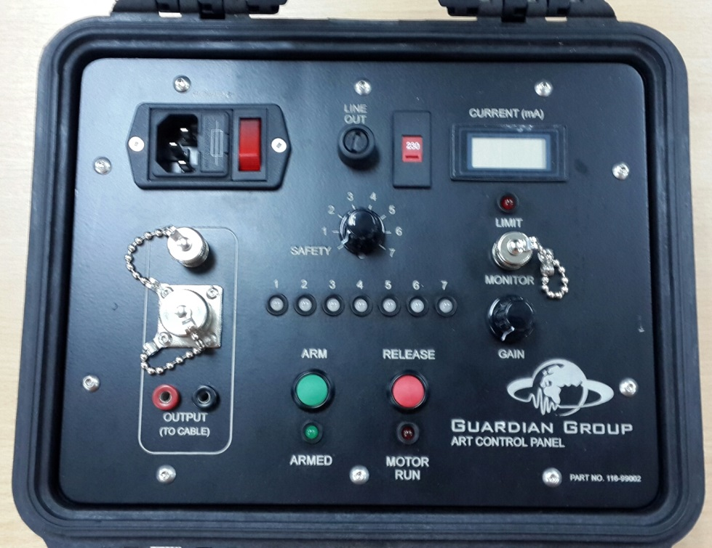

ATTACHMENT 7: EMERGENCY CONTACT NUMBER
No | Name | Position | Company | Phone Number | Email
1 | Choi Yee Xiong | PWI EIC PM9 | PCSB | +60126900095 | choi_yeexiong@petronas.com.my
2 | Ahmad Zawawi bin Abdul Rajab | PWI EIC PM9 | PCSB | +60173671650 | zawawi_rajab@petronas.com.my
3 | Win Naing Oo | FSM | DB | +60173219492 | Win.naing@dimensionbid.com
4 | Muhammad Farhaan Harun | Technical Sales and Support Eng | DB | +60122135473 | muhammad.farhan@dimensionbid.com
5 | Mohd Ismady Ismail | Head of PEXS | DB | +60128551284 | mohd.ismady@dimensionbid.com
6 | Jacob Balang | Warehouse Supervisor | DB | +60127233471 | jacob.Balang@dimensionbid.com
7 | Norfasya Ibrahim | Log Analyst | DB | +60136319279 | norfasya@dimensionbid.com
8 | Azwan Shahmee | Field Engineer | DB | +60167764829 | azwan.shahmee@dimensionbid.com
9 | Mohamad Nor Rahmat Mohamad Rafe | Technical Sales and Support Eng | DB | +60179090120 | Mohamad.nor.rahmat@dimensionbid.com

