PRODUCTION LOGGING INTERPRETATION (PLT)
STANDARD OPERATING PROCEDURE

Document Control

Version : 0.0
Release Date : 24-Oct-2019
Owner : Data Consultancy Services
Author : Baby Cintami Massaugee Abdullah
Reviewer :
Approver : Muzafar Mustafah

Private

Revision History

Version | Date | Description | Prepared By
0.0 | 24-Oct-2019 | Establishment of SSP | Mohd Azmi

Table of Contents

DESIGN 3
1.1 Objectives of Production Logging 3
1.2 General Tool Specification 4
1.3 Designing Production Logging Jobs 4
FLOWCHART 4
2.1 PLT Data Interpretation Flowchart 4
2.3 Emeraude Software 7
2.3.1 System Requirement 7
2.3.2 Software Installation via Downloaded File 7
PROCESSING 8
3.1 Emeraude Interface 8
3.1.1 Main Tab 9
3.1.2 Edit/QAQC Tab 9
3.1.3 Special Tab 9
3.1.4 Output Tab 10
3.1.5 Window Tab 10
3.2 Data Loading, Editing and QAQC 10
3.3 Wireline Preparatory Work 17
3.4 Toolstring Configuration 18
3.4.1 Standard Assembly 18
3.5 General Logging Procedures 18
3.5.1 MIT Caliper Survey 18
3.6 Field Data Processing & Delivery 19
3.6.1 Data Quality Check 19
3.6.2 Quick Look Report Submission 20
3.7 Post Survey Maintenance Procedures 20
3.8 Post Job Logistics 20
CLOSE 20
4.1 Post Job 20
4.2 MIT SSP Summary and Op-Check 22
MIT SSP Summary Checklist: 22
MIT Op-Check Checklist: 23
APPENDICES 24
5.1 Sequence of Events Template 24
5.2 Troubleshoot 25
5.3 Plan Preventive Maintenance 26
5.4 Lessons Learnt 26
5.5 Best Practices & Precautions 28
5.6 Environment Different 29
5.7 MIT Programming Sheet 30
5.8 Battery Consumption Table 31
5.9 References 33

DESIGN

Objectives of Production Logging
The objective of production logging is to provide information to the client to enable them to maximise oil recovery from their reservoirs. Initially PLT work is to profile production, but later on in the life of the field PLT work is usually to diagnose problem such as:
- Not as much oil being produced as expected.
- There is too much water being produced.
- There is too much gas being produced.
- The well has leaks or may be becoming mechanically unsound.
By diagnosing the problems and quantifying multi-phase production the client can make a commercial decision of what to do next. Industry is driven by economics; PL information can make the difference between going ahead with remedial work or even the development of an entire field.

General Tool Specification
Parameter | Specification |  | Remarks
Temperature | 350degF (177degC)
Pressure | 15,000 psi (103.4MPa)
Diameter | 1-11/16” (43mm)
Make Up Length/Weight |  | Refer to each sensor’s catalogue
Operating Voltage | +18V DC |  | Nominal
 | +13 to +23V DC |  | Range
Current Consumption at 18V |  | Refer to each sensor’s catalogue

Designing Production Logging Jobs
- Understand the objective of the run. Discuss and design the best possible way to meet the objective with client for eg. Flow profiling, Injection Profiling, Temperature Profiling, Leak Detection etc.
- Identify sensors that will be used, line speed and passes required, deployment method (memory, real time, tractor etc) and tools limitations (trajectory, P & T).
- Obtain as much as possible information for the well such as:
  - Surface production rates
  - Fluid properties (H2S & CO2), PVT Data
  - Max deviation across the interval (survey data or deviation survey)
  - Well Sketch
  - Correlation log (OHGR or CCL)
  - Estimation well stabilization time (shut in and flowing)
  - Well history or production history
  - Previous problem encountered
  - BHT & BHP
- Discuss any risk associate with the logging and contingency if failure happen (possibility of not meeting the objective due to tools/well limitation, battery limitation, tool failure or tool LIH etc). Discuss with FSM, FE in charge and client on how you can minimize the risk.

FLOWCHART

2.1 PLT Data Interpretation Flowchart

Create New Document
- Fill up Job Information, Check Document Units.
- Fill up Survey Name
- Fill up Well Deviation, Internal ID, Roughness, Perfos and Zones
- Create Well Sketch

Load General Well Data for Correlation

Load Passes Data

Perform Depth Correlation, tie-in all passes to OHGR and Well Completion

Fill up Tool Information for Density, Spinner and Capacitance

Perform Qualitative Analysis. QC the log thoroughly from bottom up. Remark for any anomaly eg. Break in slope, spikes, deflections etc. Develop a qualitative hypothesis, evaluate and write explanation to support the hypothesis in the Quick Look Report.

A

A

Produce Quick Look Report and send to client within 24hrs from data receiving. Include the details explanation if the log is unable to be quantified eg bad spinner due to clogged, mulfuction tools, ADF etc.
Is the data can be quantitatively interpret?

End
Discuss the findings with client.
Produce Quick Look Report and send to client within 24hrs from data receiving.

Continue to perform with Quantitative Analysis
- Select Interpretation settings (type, method, init, spinner and reference channel for Temperature, Pressure, Density, Capacitance and Fluid Density).
- Perform spinner calibrations and establish good calibration plot with good estimation of spinner threshold.
- Generate Vapp.
- Input PVT data.
- Define inflow area and interaction rate calculation zone for every inflow area.
- Quantify contribution from each zone / inflow area. Select the best flow model and correlation. Compare with surface well test to match.

Write Final Report and send to client within 7 days from data receiving (subject to discussion progress with client).

Present the result and findings to client.

End

Emeraude Software

System Requirement
- Required software:
  - Emeraude V5.20.03 for 32bit/64bit (ensure to install latest version).
  - Emeraude dongle key (licensed).

Software Installation via Downloaded File
- Go to KAPPA web site
(https://kappaeng.com/downloads/emeraude)
- Download the latest software needed that compatible with your computer system.
- Double click the SETUP.EXE icon to launch the software installation.
- Follow the instructions to finish the installation process.

PROCESSING

3.1 Emeraude Interface
The main program window is displayed 5 tabs option: Main, Edit/QAQC, Special, Output and Window. On each tab, there are options that can be access on top ribbons mainly for user interface. On the left of the workspace, there are control panels mainly for interpretation elements. Depending on the type of analysis selected in the current session, the control panel will show the Production Logging, DTS, or Pulsed Neutron Logging interpretation options. The interpretation workspace displays data tracks of the survey, interpretation views of the active interpretations, and also general well data and well schematic. If a new Emeraude session is created, the workspace will be empty.
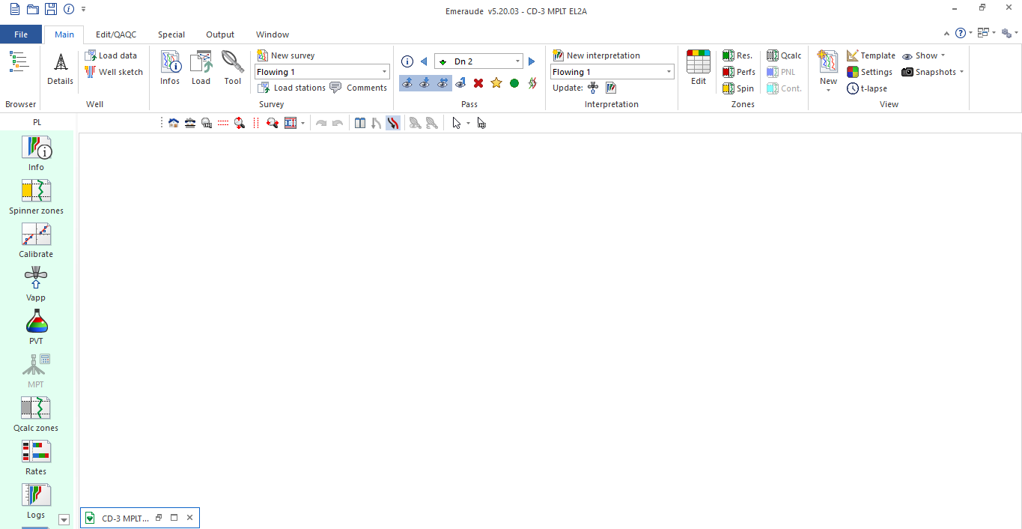

3.1.1 Main Tab
Main tab offers access to the various options/features required for the definition and workflow of an interpretation. The control panel offers (from top to bottom) the standard analysis workflow, and it is available only when an interpretation is present in the active survey. The ribbon on the top is divided in to several tool strips, with various options grouped in to each.

3.1.2 Edit/QAQC Tab
The Edit/QAQC tab offers variety of editing options to be applied to active pass, with the possibility of extending the operation to multiple passes. The ribbon on the top is divided in to several tool strips, with various options grouped to each other. The option included in Active Curve and Tool Specific tool strips are also accessed from the Browser.
Active Survey: All options in the Edit/QAQC tab apply to the active survey. A Particular Survey can be activated from the Document tool strip.
Active Interpretation: In the same fashion only one interpretation is active at a given time. The active interpretation can be selected from the Document tool strip.
Active Pass: Shown in the drop-down list, from where any pass can be selected. The active pass can be selected from Pass tool strip. By default, all passes and stations from a survey is visible. It can be hidden and shown again by clicking or . User can click to display only 1 active pass.
Depth Related Editing: Only applied to active pass, which include mainly Depth and tool shift, Stretching and Resampling. Can be selected in the Depth tool strip.
Pick Nearest Curve: Provides a way of selecting a pass by clicking on (or close to) any channel of the pass.

3.1.3 Special Tab
Give access to two specific analysis, APERM and Selective Inflow Performance (SIP).
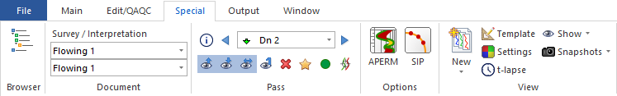

3.1.4 Output Tab
Offers different way of presenting and exporting data from the interpretation.
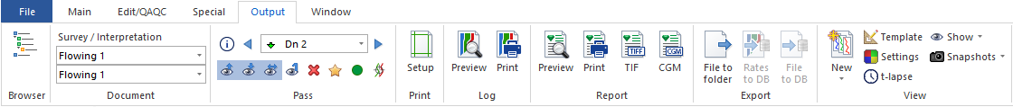

3.1.5 Window Tab
Offers the ability to open multiple documents within each module.
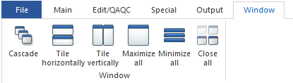

Data Loading, Editing and QAQC
- Data Loading
  - Job Information
    - Create new document by clicking the new file icon.
    - When session is initialized, select the type of analysis, PL.
    - Fill up general job information (not mandatory). One can return to this dialog at any stage later by clicking on the information button .
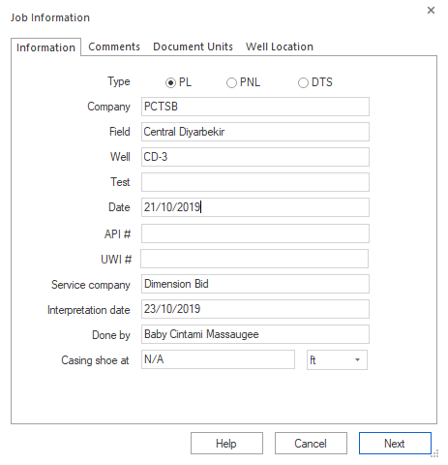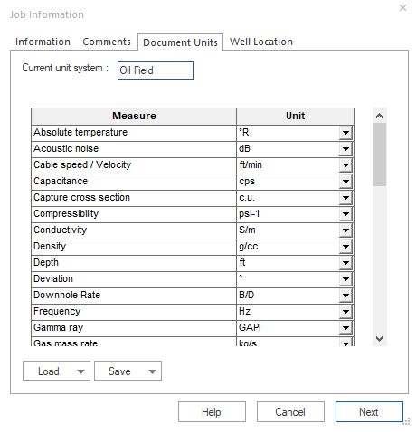
    - Change document unit accordingly. User can save their own preference unit by clicking ‘Save’ button. This will give you an option to save as default or save to a file.
    - When you proceed to click Next botton, Survey window will pop up where user can name the survey file.
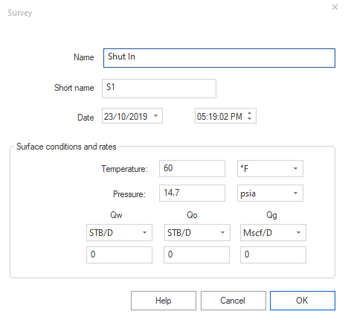

  - Well Details
    - Click Well Details option 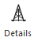 in well tool strip to input Deviation Survey (Deviation or TVD), Internal ID or Caliper Survey, Roughness, Perforation & Reservoir Zones.
    - Deviation/TVD – Allows loading either deviation or TVD vs Depth. If no data is entered, the well is assumed vertical. If a deviation survey data is available, use the Load Well Data option instead.
    - Internal Diameter – will be used for rate calculation. Can be input either known ID from Well Sketch or load Caliper survey data.
    - Roughness – There are 2 choice to enter either the absolute roughness or the relative roughness versus depth. With the relative roughness choice, it is possible to read an absolute roughness value from the relative roughness valued entered:
      - Enter depth
      - Enter a value in the ‘Relative roughness’ column
      - Click on ‘Compute’
The ‘Compute’ option indicates an absolute roughness based on the relative roughness just entered and the pipe diameter taken from the Internal Diameter tab. The absolute roughness given can be edited and a corresponding relative roughness obtained.
Note: If no roughness is entered, it is assumed to be 0 at all depths.
    - Perforations – When they are created, they are displayed as red markers in the ‘Z track’. They will influence the calculations as they are used to define the initial position of the inflow zones, which emeraude assigns the contributions. Name the perforation sand accordingly. If ’Squeezed’ box is checked, it will appear darker on the ‘Z track’.
    - Reservoir zones – When they are created, they are displayed as green markers in the ‘Z track’. The reservoir zones do not influence the rate calculations but they are essential if the SIP option is used. Name the reservoir zone accordingly.

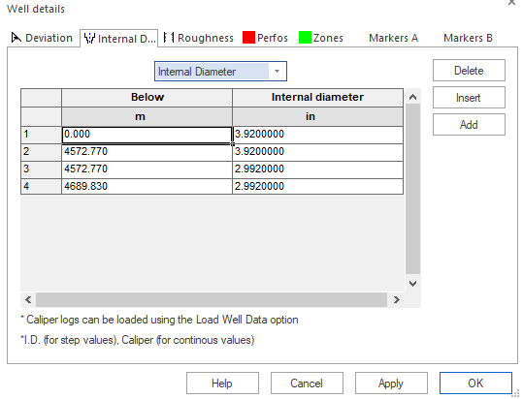

  - Well Sketch
    - Click Well Sketch option in well tool strip to create and edit a Well Sketch view. Creation of multiple WS is available in the ribbon. WS can be created from a copy of a previous one and a time stamp can be associated to each WS.
Note: IDs and length of the different components are only for sketching purposes, and are not taking into account in the rate calculation.

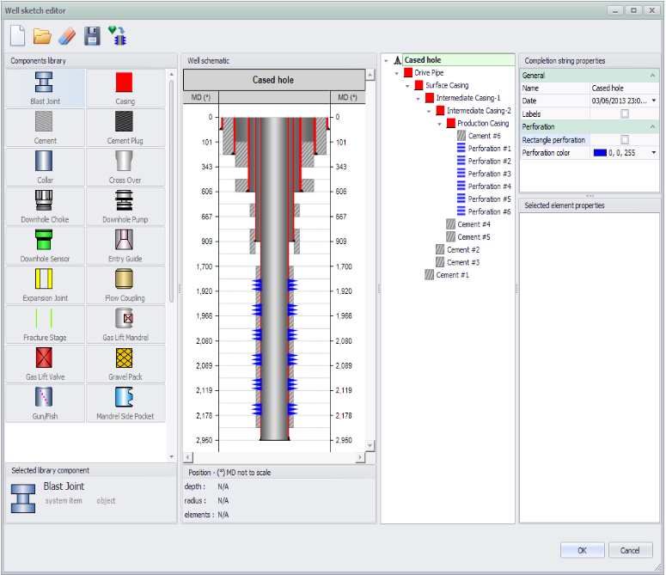

    - Drag and place each component inside the well schematic. Define the element label and properties. Each element requires a start and stop depth.
    - Right click on the well schematic allows the user to delete the element. If an element is deleted, all the elements inside are also deleted.

  - Load Well Data
    - General well logs can be loaded from in the well tool strip. Data that can be upload are as follows:
      - Open Hole Gamma Ray (for depth correlation/matching)
      - Deviation survey
      - Caliper Survey
      - Reference CCL
    - The channels must be uploaded from a versus depth file. The format can be LIS, LAS, DLIS, or ASCII.

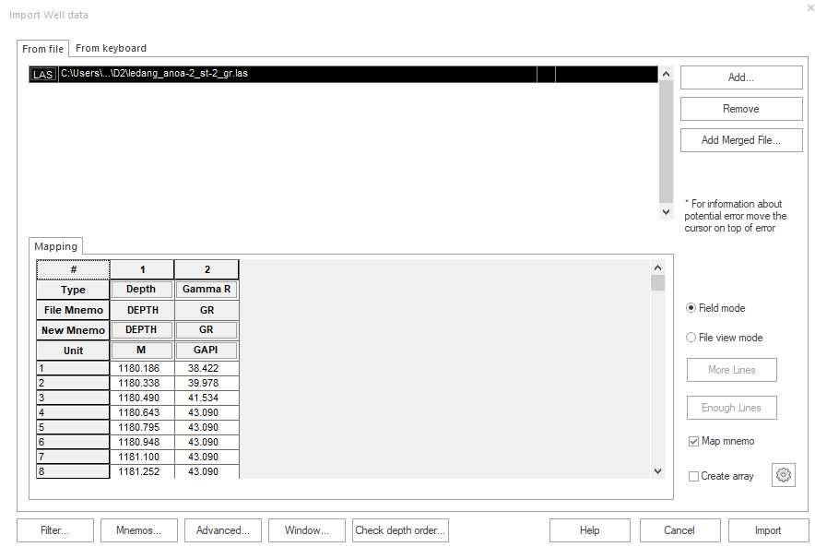
    - Define channel for your reference (Depth and GR) and once OK, click import.
    - GR vs Depth will be shown in the tracks. Check your depth of interest if the reference log given is covered.
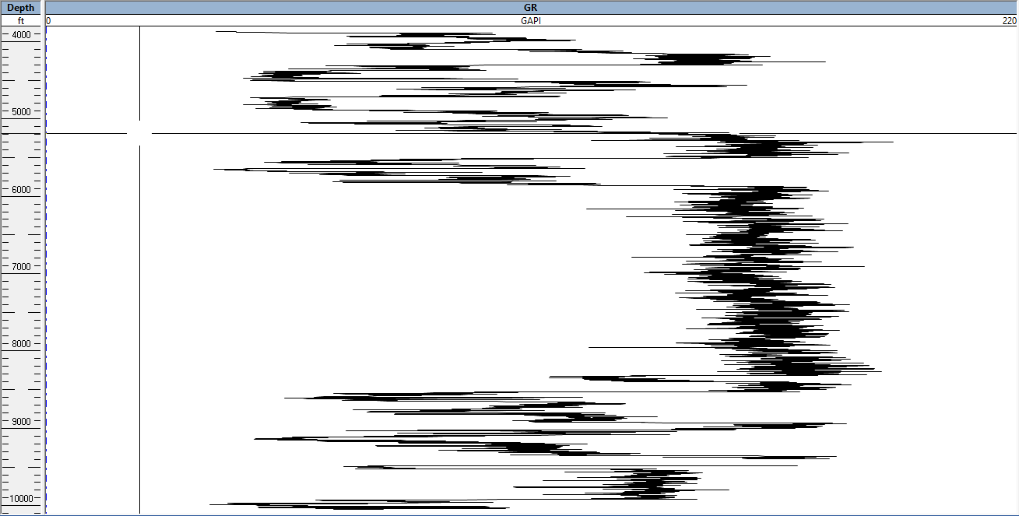

Note: If there is no OHGR present, one can drop a GR from one of the PL passes (normally the lowest up pass) and drop it into the general well data. Note that by doing so, the passes will be on depth among themselves, but may be off the actual depth.

  - Load
    - PL data is loaded using  from the survey tool strip.
    - User can upload PL data passes for each up and down pass(es) by clicking Add button. Select all of PL passes and click OK.
    - Emeraude pop up window will let you choose either to define mnemonics that are unrecognized now or later. If you choose later, all channels in mapping window will show in red for those undefined items (either type, file mnemo, or unit).
    - Filter button will allow you to do quick mnemonic filterations.
    - After all channel are defined, select type of pass (down or up) according to user file naming. The index number can be assigned and will reflect the curve color of each pass later in the workspace display tracks.
Note: If there is still error pop up that disable you to click Import button for next step, you can move cursor to the warning button to see the error.

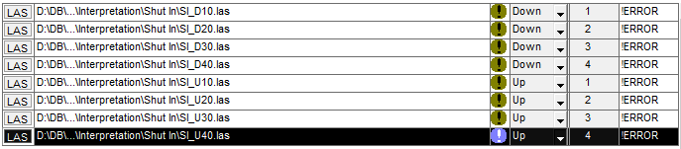

    - Click Import button.

  - Load Stations
    - PL station data is loaded using from the survey tool strip.
    - Loading stations (loading vs time) is very similar to loading survey data (loading vs data).
    - If a Depth column is found in the file, then Emeraude will use this information to assign appropriate depth to the measurement. When no depth information is found, you can input the station depth in the box as below:

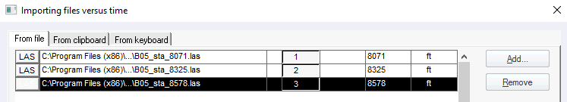

    - If depth is not entered at this level, clicking import button will prompt the user to enter the station depth in the box below:

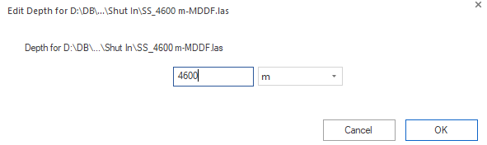

  - Tool Info

    - Click 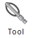option to enter additional parameters required such as Tool OD, Density, Spinner and Capacitance.
- Tool OD – insert tool OD. Used for friction calculation when relevant.
- Density – used to characterize the type of density tool(s) used. For gradio, a drop down list indicates the response type. Choose density tool based on type of density you are using.
- Spinner – Select which spinner will be used for the interpretation and insert spinner blade diameter.
- Capacitance – defined by a calibration chart together with in-situ measurements in 100% water and 100% Hydrocarbons. Write in-situ measurement based on the log observed. Then, choose default chart based on type of tool you are using.
There are two possible calibration mode to choose:
  - Chart is count/sec vs dielectric values; in-situ values are dielectric.
  - Chart is Water holdup vs normalized tool response; in-situ values are count/sec.

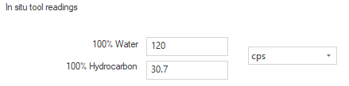

- Data Editing
  - Pass Shift
    - Depth shift for matching purposes can be defined for an entire pass. Click in the Depth tool strip.
    - Maximize the GR plot by double clicking on its title bar, and zooming in depth interval.
    - The depth matching is performed manually for each of the present passes.
    - Click for one pass at a time and select pass from the list or using the Pick Nearest option 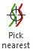 if you view multiple passes.
    - Click the pass shift button

Wireline Preparatory Work

To prevent any hiccup while performing MIT Caliper survey job, tubing clearance must be conducted to clear any obstruction until set depth.
- Prepare wireline surface equipment.
- Ensure master valve and crown valve is fully closed prior to opening tree cap.
- Rig up PCE and pressure test up to client’s requirement, i.e. 3000 psi for 15 minutes.
- Make up wireline toolstring as per job program and zero at Tubing Head Flange.
- Run in Hole (RIH) with Drift or Gauge Cutter to No-Go depth or top of plug (refer to well schematic). Record the No-Go depth and Pull out of Hole (POOH).


If the clearance between tool and tubing is big and there is additional tubing below the No-Go, it’s recommended to run the sinker bar until 2 meter above the EOT.

- RIH with sinker bar to tag Total Depth (TD) or Held-Up Depth (HUD). Record TD and POOH.
This procedure is ONLY valid if the MIT need to be run out of casing

- For a short string well, RIH sinker bar to 2 meter below No-Go nipple.
- Reconfirm the status of Sliding Side Door (SSD) by running shifting tool, if necessary.
- Retrieve the Wireline Retrievable Surface Control Subsurface Safety Valve (WR-SCSSV) / Insert valve if the well is fitted with insert valve per standard procedure.
Synchronization of DTR with SLS Odometer can be performed during slickline operation.

Toolstring Configuration

Standard Assembly
- Wireline Toolstring (varies depending on TCC and dummy run)
- Knuckle Joint
- X-Over SLS to Logging Tools
- Memory Battery Holder (ABM)
- Ultrawire Memory Tools (UMT007)
- Casing Collar Locator (CCL)- Optional
- Production Gamma Ray (PGR) – Optional
- Production Knuckle Joint (PKJ) – at least 1ea
- Production Roller Centralizer (PRC) – PRC034 is recommended
- Multifinger Imaging Tools
- Production Roller Centralizer (PRC) – PRC034 is recommended
- Bullnose with Terminator (BULL)

General Logging Procedures
Before the beginning of any work, ensure that all equipment comply with the client’s Safety Standards. Conduct pre-job safety meeting with all personnel involved on location detailing program, pressure limitation, safety procedures, and personnel responsibilities.

MIT Caliper Survey
The objectives of MIT Caliper are:
- To determine the level of corrosion inside the tubing
- To determine any anomaly found in the tubing such as deposition, possible hole and damage.
This survey is performed under shut in condition, after the well had been stabilized for 12-24 hours (depending on client’s requirement).
Operation Procedures:
- Shut in well for required duration prior to MIT Caliper Survey. Tubing clearance check must be performed prior to perform the survey.
- Repeat steps in 2.6.2 and record battery hook-up time. Make sure the housing is tightened by using appropriate spanner.
Calibration must be performed prior to run and after run

- Make up assembly to be run as in 3.4.1.
- Open the well and let the tool inside the lubricator for 5 minutes
- RIH with average speed of 30 m/min to set depth. The RIH speed might differ from the actual program thus read the program carefully. Also, vigilantly take several station stops to pick up pulling weight during RIH.
- Once at set depth, wait until tool open time and give 5 minutes allowance before starting the logging. Log MIT to 2 m-MDTHF at 10 m/min. Once at 2 m-MDTHF, wait for the tool close time and give 5 minutes allowance before POOH.
- Recover the MIT tools from lubricator. Download the data from UMT and DTR data.
- Perform the after job calibration to check the percentage of finger worn out. Percentage allowable is less than 1% from the ID. Please check the condition of fingers prior to perform after job calibration.
- Check the data reliability before rigging down all the equipment. If the data is not satisfactory, discuss with Supervisor for the possibility of re-run the MIT survey.
- Produce Quick Look Analysis and determine the condition of the tubing ID. Send the raw data together with Quick Look Analysis to the Log Analyst for Final Report.
MIT MUST be conducted from the Bottom to Top or POOH. Do not attempt to go down if the tools stuck while POOH and fingers still open. Do not attempt to log down while fingers are still open. This may cause serious damage to the fingers.

Field Data Processing & Delivery

Data must be sending to Client and town within 24 hours after completing the survey.

Data Quality Check
- Follow the step from 2.6.3 for data processing.
- Check the data for all fingers. Observed the pattern of the finger reading. At the accessories and joint, the changes of patterns should be the same for all fingers.
- The gap between fingers should be as same as possible.
- Identify all the well accessories to tally with the well schematic.
- Cross check the finger’s reading in the log vs nominal ID of the tubing.
- Perform depth shift/depth correlation on the MIT data. You may use the well accessories as a reference (TRSCSSV or No Go Nipple) for depth shift/depth correlation.
- Perform the after job calibration to check the percentage of finger worn out.
Percentage allowable is less than 1% from the ID.

- Please check the condition of fingers prior to perform after job calibration. Notify the Log Analyst if the percentage is more than 1%.
- If data is unsatisfactory, discuss with Log Analyst and Supervisor for the possibility of re-run.

Quick Look Report Submission
- Fill up the template of the MIT Quick Look Report. Make sure the version is the latest.
- Compile the report together with Interactive Plot and after job calibration file.psc that generate from the software.
- Send the Quick Look Report to the client and all personnel in charge.
- Send the Raw Data and Calibration File to Log Analyst for Final Report.

Post Survey Maintenance Procedures
- Ensure the MIT Tools is clean from any debris, dirt, and grease. Use WD-40 to clean all debris, dirt, and grease.
- Inspect all fingers and actuator for any damage and replace if necessary.
- Inspect all additional tools for any damage and defect.
- Inspect all the O-rings for any damage and replace if necessary. It is recommended that the O-rings seals be changed every time for External O-ring and after 5 times for Internal O-ring.
- Please refer to the Tool Maintenance Checklist for the items need to be changed.
- Record all the maintenance in the Tool Utilization Record and Tool Maintenance Checklist.

Post Job Logistics
- After completing the maintenance, make sure all the MIT Tools are safely packed inside the Pelican case.
- Carry out final check utterly and specify the quantity of consumables and accessories for future reference. Request for additional items should the materials is in short supply.
- Discuss with Wireline Supervisor concerning the next MIT Caliper Survey job. If there is no other planned job, FE need to send back the MIT Tools to base and prepare Material Transfer Request (MTR) documentation.

CLOSE

Post Job
- Post Job Reporting and Paperwork.
- Submit any lessons learnt and improvement suggestion to FSM.
- Follow up with the logistic team for the equipment returned from location.
- Perform bench test prior to handover the tool to Lab Technicians. If post job servicing not performed, please perform the post job maintenance before proceeding to bench test.
- Attend debriefing with FSM.

MIT SSP Summary and Op-Check

MIT SSP Summary Checklist:

MIT Op-Check Checklist:

APPENDICES

Sequence of Events Template

Troubleshoot
Hardware & Software Problems
Symptoms | Possible Problems | Solutions
UMU001 failing to communicate with the UMT. | Software for UMU001 not installed | Install the software for UMU001
UMU001 failing to communicate with the UMT. | USB failed to communicate | Unplug and plug the USB
UMU001 failing to communicate with the UMT. | UMU001 problem | Change with the backup UMU001
Unable to launch the UW Memlog software and Warrio Acquisition | Wrong Key Code inserted | Confirm the Key Code to tally with key dongle
 | Compatibility problem | Check the computer operating system to tally with software installed
 | Software or drivers are corrupt or damaged | Upgrade to latest software version or reinstall (ensure USB devices disconnected).
Date recorded to memory is noisy | Low voltage of the battery | Check the battery voltage or change the battery
Data is out of the tools specification | Sensor/Tools Problem | Perform physical check on tools condition for any damage or defect. Refer to the tools manual for maintenance
Data is out of the tools specification | The MIT may need to be recalibrated | Check the condition of fingers. Replace if necessary and calibrate again
Data is out of the tools specification | Setting of software/service not correct | Please refer to the MN-UW memlog and MN-Warrior manual for setting
No data recorded | Battery blown | Change new battery
No data recorded | UMT not recorded | Check the profile program or change with new UMT  Perform physical check on tool for any damage or defect

Plan Preventive Maintenance
As part of Dimension Bid – Cased Hole Services quality management requirement, all equipment and tools to be used for client must be reliable with traceable calibration record.
It is our main priority of DB-CHS to serve our clients with the best quality and reliable tools in order to acquire high quality data.
To meet this objective, the standard tools testing and calibration procedure had been established and implemented by CHS team accordingly.
The MIT are subjected to PPM every 6-months to maintain its reliability and accuracy. This involves physical inspection on internal electronic section, fingers condition, and will be tested using Oven for heat test. If the result from the Oven is off, the MIT Tools needs to perform maintenance or send to supplier for major maintenance.

Lessons Learnt
Case 1: MIT24F finger broken after survey.

Incident 1: 2ea MIT24F finger broken
Date | 22 May 2017
Platform | Bunga Orkid Charlie
Well | BOC 14
Job | MIT24 Caliper Survey
BHA | Wireline toolstring + MIT24F BHA

During retrieve the MIT from lubricator, engineer found 2ea of MIT24F finger not properly close. When engineer try to open the fingers, he found that 2ea fingers were broke.

Engineer suspect the debris such as sand was blocking the spring and finger clamp that cause spring broke. Engineer perform servicing and change the finger.

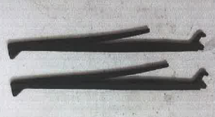
Figure 14. Spring broke

Incident 2: 24ea MIT24F finger broke
Date | 23 May 2017
Platform | Bunga Orkid Charlie
Well | BOC 14
Job | MIT24 Caliper Survey
BHA | Wireline toolstring + MIT24F BHA

During retrieve the MIT from lubricator, engineer found 24ea of MIT24F finger not properly close. When engineer try to open the finger, he found that all the fingers spring already broke.

Engineer suspect the debris such as sand was blocking the spring and finger clamp that cause spring broke. Job was suspended due for the investigation. Sample of finger was sent to supplier for investigation. Detail of well condition and properties were check. Based on the investigation, supplier make the conclusion the finger broke were due to exposure to high content of Mercury (Hg) not because of blockage of debris. MIT fingers are following the NACE specification but it’s has the limitation.

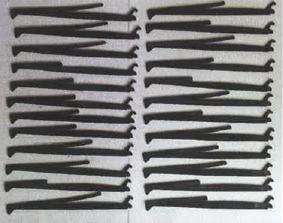
Figure 15. Spring broke

Lesson Learnt: MIT fingers from Sondex are follow the NACE specification but mercury are very extremely corrosive. It’s recommended to check the content of mercury and use chemical inhibitor to reduce the effect of mercury on tools.

Best Practices & Precautions
- Determine the well properties to make sure the tools are within the requirement.
- Perform quick bench test prior to run.
- Record the battery usage to avoid waste of battery.
- Always perform before and after calibrations every run.
- Check the fingers tip and actuator condition before and after every run.
- Always check O-ring conditions after every run.
- Make sure tools are cleaning and in good condition before storage and run.

Environment Different
O-ring seals
Fluorocarbon elastomers (Viton®) exhibit very good thermal and hydrocarbon resistance but can be attacked by a number of commonly encountered oilfield media. Corrosion inhibitors will cause embrittlement, while sour wells containing Hydrogen Sulphide (H2S) and Carbon Dioxide (CO2) may cause softening with consequent reduction in the elastomer’s mechanical properties.
Hydrogenated Nitrile Rubbers (HNBR) have proven invaluable in extending the boundaries of elastomeric seals in aggressive environments. These materials display superior resistance to aggressive fluids such as sour crude oil or gas, lubricating oil additives and amine corrosion inhibitors where fluorocarbon (Viton®) seals are less effective.
Hence the type of O-ring used will depend on the environment. Under normal conditions Viton® can be used, however, in harsher environments, such as in sour wells, HNBR will be more reliable.
The required O-rings sizes can be cross checked with the O-ring tables in the next section.
O-Ring Cross Check Table
Tool | MIT TOOLS
Tool Code | MIT24F
NO | O-RING SIZE | QUANTITY PER NO. OF RUNS
NO | O-RING SIZE | 1 | 5 | 10 | 15 | 20
1 | O-RING SZ-028 | 4 | 20 | 40 | 60 | 80
2 | O-RING SZ-211 | 14 | 70 | 140 | 210 | 280
3 | O-RING SZ-012 | 10 | 50 | 100 | 150 | 200
4 | O-RING SZ-124 | 6 | 30 | 60 | 90 | 120
5 | O-RING SZ-118 | 4 | 20 | 40 | 60 | 80
6 | BACKUP O-RING 118 | 2 | 10 | 20 | 30 | 40
7 | BACKUP O-RING 124 | 2 | 10 | 20 | 30 | 40

Conveyance in Deviated Wells
As wells become more highly deviated, or their profiles become more challenging, it is increasingly difficult to reach the targeted depths. Frictional resistance caused by the toolstring lying on the low side of the well can inhibit the operation from reaching lower depths.
Roller conveyance tools lift and support the toolstring off the low side of the well. Large rollers eliminate tool contact friction, making it easier to convey the toolstring to target depth and achieve the results expected.
Corrosion and Chemical Effect
'NACE Specification' refers to the international standard NACE MR0175 / ISO 15156, which was originally written by the National Association of Corrosion Engineers. This standard lists materials that are suitable for use in H2S-containing environments in oil and gas production. 'NACE Spec' is a commonly used but often misunderstood phrase within the Wireline Logging industry. 'NACE Spec.' does not mean 'H2S Proof'.
Hydrogen Sulphide reacts with some metals releasing hydrogen into the structure of the metal and causing embrittlement. This is particularly significant with components that are already under stress or are required to deform elastically (e.g. springs). On some non-ferrous components the effect of H2S is merely surface discoloration and mild surface pitting which in general is no cause for concern.
Carbon dioxide dissolves in water to form a weak acid which may also corrode metal components and further complicate the effects of H2S. It is also common to see the effects of CO2 on O-rings and similar elastomeric seals. The CO2 penetrates the structure of the rubber at high pressure, but as the tool is retrieved from the well the pressure decreases rapidly and the O-ring becomes swollen. O-rings exposed to CO2 in this manner should not be reused. Sondex can supply more resistant O-rings which, although more expensive, perform better in high CO2 environments.
Mercury is extremely corrosive to some of the metals. Under very rare circumstances wells may produce native Mercury (Hg). This is due to two possibilities:
  - Mercury has been used to lift trash from the well (rare nowadays due to environmental concerns)
  - Mercury is freely flowing into the well - very rare but can happen.

MIT Programming Sheet

Battery Consumption Table

References
Asraf, N. (2017). DBSB-CHS-03: Standard Operation Procedures for MIT. Kemaman, Malaysia: Cased Hole Services, Dimension Bid Sdn Bhd.
Asraf ,N. (2017). CHS-MIT-SP002: MIT Ultrawire Programming and Downloading. Kemaman, Malaysia: Cased Hole Services, Dimension Bid Sdn Bhd.
Asraf ,N. (2017). CHS-MIT-SP003: MIT Data Delivery. Kemaman, Malaysia: Cased Hole Services, Dimension Bid Sdn Bhd.
Ahmad ,A. (2019). TRAINING MODULE: TM-01. Kemaman, Malaysia: Cased Hole Services, Dimension Bid Sdn Bhd.
Ahmad ,A. (2019). TRAINING MODULE: TM-02. Kemaman, Malaysia: Cased Hole Services, Dimension Bid Sdn Bhd.
Cased Hole Services, Dimension Bid Sdn Bhd. (2017). CHS-RPSL-240517: Problem Report – 2 MIT Finger Broken. Kemaman, Malaysia.
Cased Hole Services, Dimension Bid Sdn Bhd. (2017). CHS-RPSL-250517: Problem Report – 24 MIT Finger Broken. Kemaman, Malaysia.
Cased Hole Services, Dimension Bid Sdn Bhd. (2017). FORM 88 MIT – MIT Maintenance Checklist (Rev. 1). Kemaman, Malaysia.
John, B. (2002). Memory Production Logging: Downhole Battery Pack. Hamsphire, UK: Sondex Ltd
Ferry, V. (2007). Multifinger Imaging Tool: MN-MIT034. Hamsphire, UK: Sondex Ltd
Paul, L. (2005). Multifinger Imaging Tool: MN-MIT027. Hamsphire, UK: Sondex Ltd
Sondex. (2012). Ultrawire Memory Tools: MN-UMT007 (RevA). Hamsphire, UK: Sondex Ltd
Robert, H. (1992). Casing Collar Locator: MN-CCL015. Hamsphire, UK: Sondex Ltd
Robert, H. (2002). Production Gamma Ray: MN-PGR-020. Hamsphire, UK: Sondex Ltd
Ferry, V. (2005). Production Knuckle Joint: MN-PKJ-GO. Hamsphire, UK: Sondex Ltd
Paul, L. (2005). Multifinger Imaging Tool: MN-MIT027. Hamsphire, UK: Sondex Ltd
Neil, H. (2002). Production Roller Centralizer: MN-PRC034. Hamsphire, UK: Sondex Ltd
Susan, A. (2002). Bullnose Ultrawire Terminator: MN-BUL. Hamsphire, UK: Sondex Ltd
Sondex. (2014). Adapter Manual: General Manual (RevJ). Hamsphire, UK: Sondex Ltd
John, B. (1997). Memory Battery Holder: MN-MBH014. Hamsphire, UK: Sondex Ltd
Ferry, V. (2006). Chemical & Corrosion Effect on Logging Tools. Hamsphire, UK: Sondex Ltd

