SLICKLINE ASSISTANT
WORKBOOK

IMPORTANT NOTE:

1. Your point of reference to complete this workbook may be obtained from the following
- Training Manual and any other training materials provided together with this workbook
- Your Trainer, Assessor (Slickline Operator), Verifier (FSM) or senior colleagues
- SOP / Quality Procedures & Processors
2. The completion of this Workbook is a joint effort and responsibility between you and your assessor therefore you have the obligation to request from your assessor to be assessed upon your completion of each topic
3. The completion of this Workbook is part of the MANDATORY requirements which you must fulfill to qualify for a promotion
4. Your training program is mostly self-driven, including this Workbook. It requires individual initiatives, dedication and commitment to complete the process.

NAME
DATE OF JOIN
CONTACT NO.
RECEIVED DATE
DATE COMPLETED

C. DOWNHOLE EQUIPMENT

  - List out all basic running and pulling tools
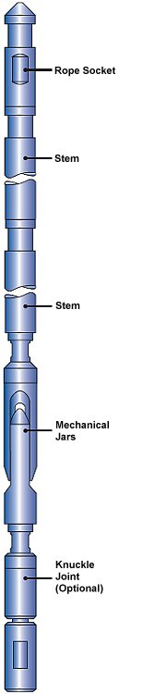
No. | Items
1
2
3
4
5
6
7
8
9
10
11
12
13
14
15
16
17
18
19
20

Primary Wireline Tool-string


Tool-string configuration according to requirement. Introduction to

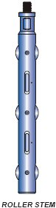

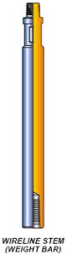
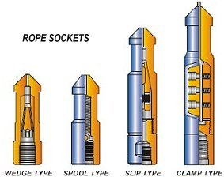

- rope sockets

- stem lead

- tungsten stem

- roller stem

- jars

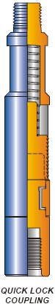
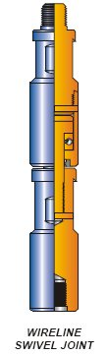

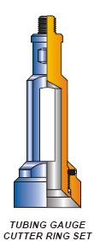


- knuckle joints

- swivel joints

- quick-lock coupling
- gauge cutter

- Blind Box


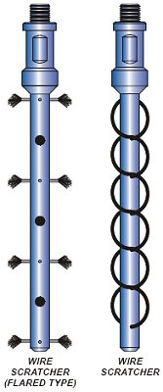


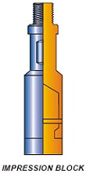

- lead impression box

- swage

- wire scratcher

- tubing end locator

- wire recover tool

Fill in below Table

A. Size of wire that use in DB  1. ________________________________________  2. ________________________________________  3. ________________________________________ | B. Breaking point of each wire  1. ________________________________________  2. ________________________________________  3. ________________________________________
C. Type of wire used in DB  1. ________________________________________  2. ________________________________________  3. ________________________________________ | D. How to test if wire is good or not  1. ________________________________________  2. ________________________________________  3. ________________________________________
E. Why do we need to check the tools before running in hole (RIH)?

F. What do we need to do if the tool is damage or lost in hole?

G. What do we need to do if equipment failed to work?

