10 sep 2023 to 14 sep 2023 ( ALI BASRI BIN BAKRI )

Assist Toolman with servicing tool.

- SERVICE TOOL
*Remove the rust from tools, in order for the tool to be usable in the long term.

The Example of tools.
- Tebular jar
- Cross over
- Lead impression block (LIB)
- Normal stem
- Knuckle joint
- Tubing drift

- PULLING TOOL ( RB and RS )
Servicing RB & RS by part.

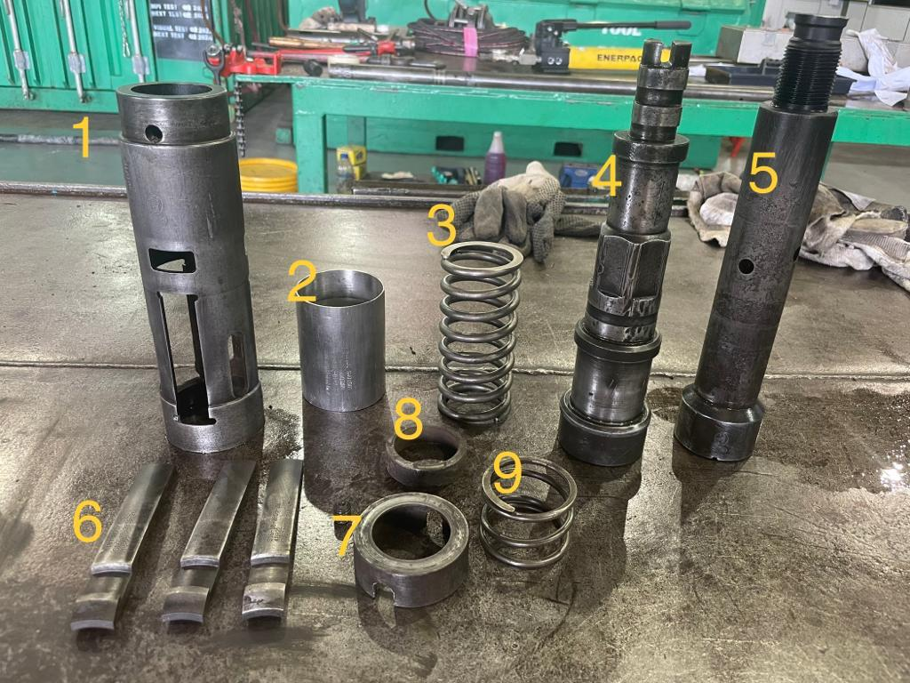

- Skirts
- Body sleeve
- Core spring
- Top sub
- Core
- Dog
- Retainer ring
- Washer
- Dog spring

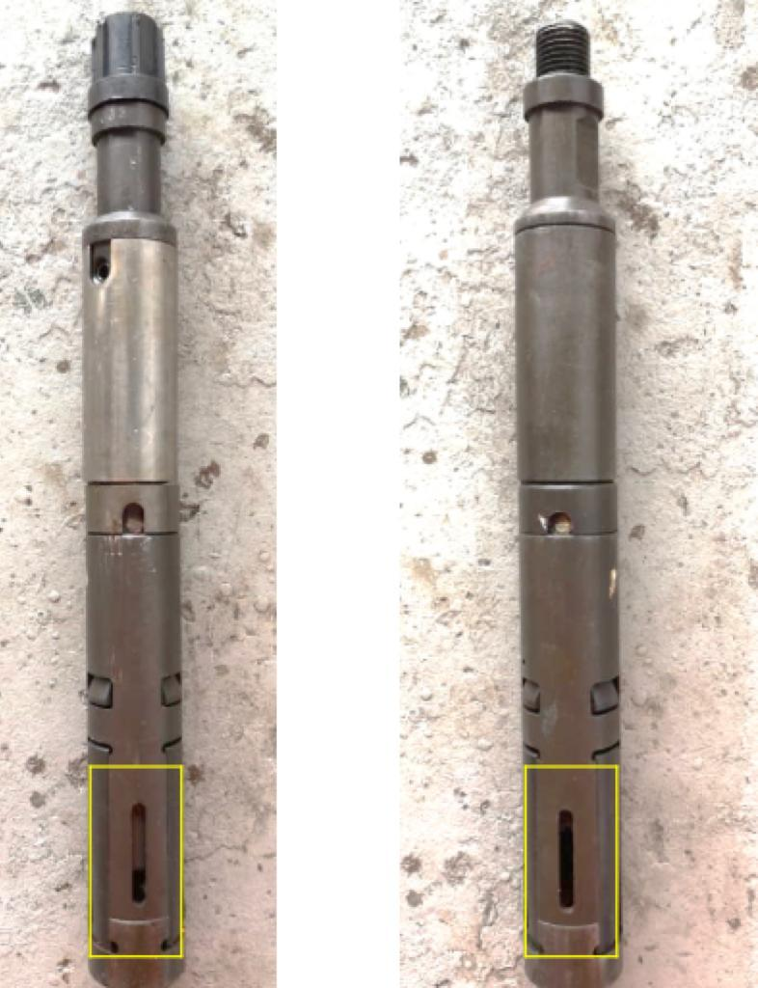
RB RS
The difference between RB & RS is only in the length of the core.
> RB ( longest core )
> RS ( short core )

> Tool for ‘R’ and ‘S’ series
- Pinning tool
- Releasing tool

Longest core | Will have short reach
Shortest core | Will have long reach

> Can be changed to either of the 2 other types by changing the core.

