

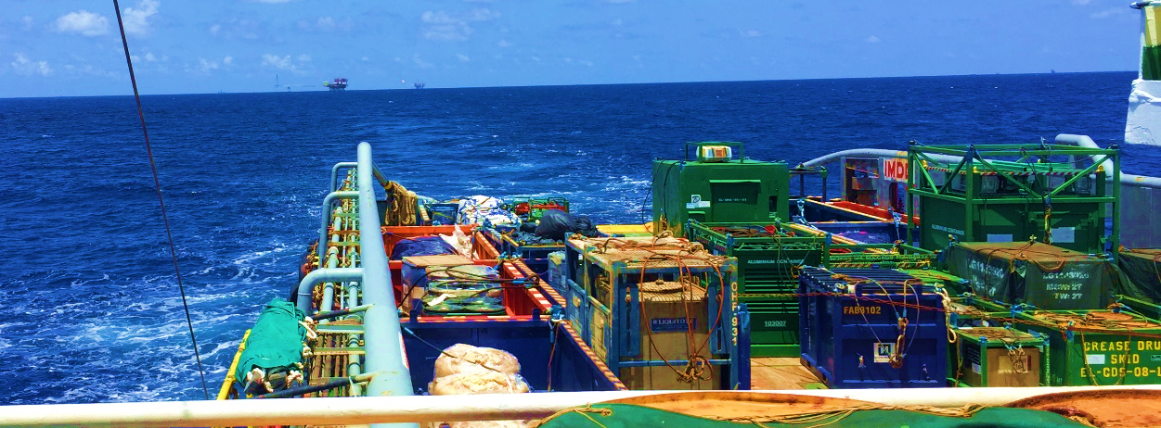
END OF JOB REPORT

MIT LOGGING
TEMBUNGO-BRAVO
B09L
Prepared by | Reviewed by | Received by
Clement Emang  Field Engineer | Amrie Zulkifli  Account Manager | Aina  Well Integrity Engineer

Contents
1. CLIENT DETAILS 2
2. JOB DETAILS 2
3. PERSONNEL DETAILS 2
4. INTRODUCTION 3
5. OBJECTIVES 4
6. WELL SCHEMATIC 4
7. SEQUENCE OF EVENT/OPERATION SUMMARY 6
8. SUMMARY 7
9. ATTACHMENT 7

CLIENT DETAILS

CLIENT : PCSB SKA
FIELD : TEMBUNGO
PLATFORM/RIG : TBG-BRAVO
WELLS NAME : B09L
ENGINEER IN CHARGE :
COMPANY MAN : Julius, Zaid

JOB DETAILS

MAIN OBJECTIVE : MIT LOGGING
MOBILIZATION DATE : 22/9/2023
TYPE OF SERVICES : EMITE (MEMORY MIT LOGGING)
CONVEYANCE : Deleum Slickline Unit

PERSONNEL DETAILS

DIVISION : EMITE
FIELD ENGINEER : Clement Emang
3RD PARTY COMPANY : DELEUM
3RD PARTY PERSONNEL : Douglas, Zaidie, Mazlani
FIELD OPERATION SUPPORT : Faris Firdaus
ACCOUNT MANAGER : Amri Zulkifli

INTRODUCTION

- The proposed work scope for TBG-BRAVO is to perform MIT logging using MIT24F to inspect the tubing internal condition and integrity by analysing any corrosion, erosion or physical damage prior to Plug and Abandonment.
Mechanical | MIT24F
Outside Diameter | 1-11/16”
Make up Length | 50.6”
Housing Material | Inconel 718 / Stainless Steel 17-4
Finger Lengths | 7”
Number of Fingers | 24F
Radial Accuracy | ±0.02”
Radial Resolution | 0.003”
Measurement Range | 1-3/4”(Min) 7”(Max)
Circumferential Spacing | 0.23”(Min) 0.92”(Max)
Finger Tip Radius | 0.05”
Finger Tip Width | 0.063”
Finger Contact Force | 0.75lbs(Min) 1.25lbs(Max)
Logging Speed | 30ft/min(Min) 60ft/min(Max)
Environmental
Pressure Ranges | Up to 15,000 psi
Temperature Rating | 177°C (351°F)
Electronic
Current Consumption | Logging <30mA Motor <400mA

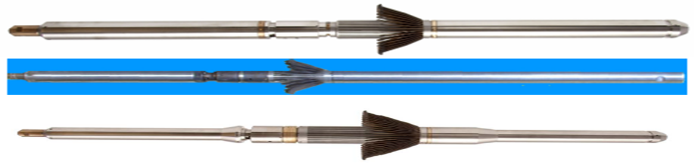

OBJECTIVES

▪ To provide MIT survey to inspect the tubing internal condition and integrity by analysing any corrosion, erosion or physical damage prior to Plug and Abandonment.

PLANNED
Run | WELL | RUN | INTERVAL
7 | B09L | MIT LOGGING | 11447 ft-MDTHF to surface

WELL SCHEMATIC

WELL NAME : B07L
WELL TYPE : Dual Producer
TUBING DETAILS : 2-7/8”
CASING DETAILS : 9-5/8”
CITHP (PSIA) : -
A-ANNULUS PRESSURE : N/A
MAXIMUM DEVIATION : 52.8 DEG
FIELD ENGINEER : CLEMENT EMANG
CREW : -
3RD PARTY REP / CONVEYANCE : DOUGLAS, ZAIDIE, MAZLANI

SEQUENCE OF EVENT/OPERATION SUMMARY

ACTUAL
Run | WELL | RUN | INTERVAL | STATUS
5 | B09L | MIT LOGGING | 10361 ft-MDTHF to 5100 ft-MDTHF | COMPLETED
6 | B09L | MIT LOGGING | 5300 ft-MDTHF to 20 ft-MDTHF | COMPLETED

Date | Description/Operation Summary
29/10/2023 | - Deleum run TCC but encounter HUD at 10361 ft-MDTHF. Inform WSS. After discussion with WSS/town, decided to run MIT until 10 ft above HUD. New interval for MIT logging is 10351 ft-MDTHF to 20 ft-MDTHF  - Perform MIT run from 10351 ft-MDTHF to 5100 ft-MDTHF  - Toolstring:RS + Swivel + 5ft stem + 3ft stem + KJ + ABM + UMT + PKJ + PKJ + PRC + MIT24 + PRC + BUL  - RIH with 120 ft/min, slow at accessories and pick up weight every 1000ft.  - Reach 10351 ft-MDTHF. Wait for finger to open.  - Log up 30 ft/min to 5100 ft-MDTHF.  - Reach 5100 ft-MDTHF. Wait for finger to close.  - POOH to surface  - Disconnect tool from slickline toolstring  - Disconnect battery  - Download data.
30/10/2023 | - Perform MIT run from 5300 ft-MDTHF to 20 ft-MDTHF  - Toolstring:RS + Swivel + 5ft stem + 3ft stem + KJ + ABM + UMT + PKJ + PKJ + PRC + MIT24 + PRC + BUL  - RIH with 120 ft/min, slow at accessories and pick up weight every 1000ft.  - Reach 5300 ft-MDTHF. Wait for finger to open.  - Log up 30 ft/min to 20 ft-MDTHF.  - Reach 20 ft-MDTHF. Wait for finger to close.  - POOH to surface  - Disconnect tool from slickline toolstring  - Disconnect battery  - Download data.

SUMMARY

- Successfully achieve all the objectives.
- Depth control and QC were performed based on TRSCSSV as reference. Minimum ID at the seal bore reading was in between tolerance
- All fingers working good and fully open throughout the logging and overall log quality is good and interpretable
- Field Quick Look Report shows that the MIT24F detects light to moderate corrosion in the range between 10%-30%
- There is no possible leak that exceeds 70% of penetration in tubing wall which classified as possible hole in the well.

ATTACHMENT

NO | DOCUMENT
1 | Daily Offshore Report
2 | Field Quicklook 1ST Run
3 | Field Quicklook 2nd Run
4 | MIT Log 1ST Run
5 | MIT Log 2nd Run

